**SUPPLEMENTARY INFORMATION**

**Supplementary FIGURE 1. Vallés-Saiz et al**



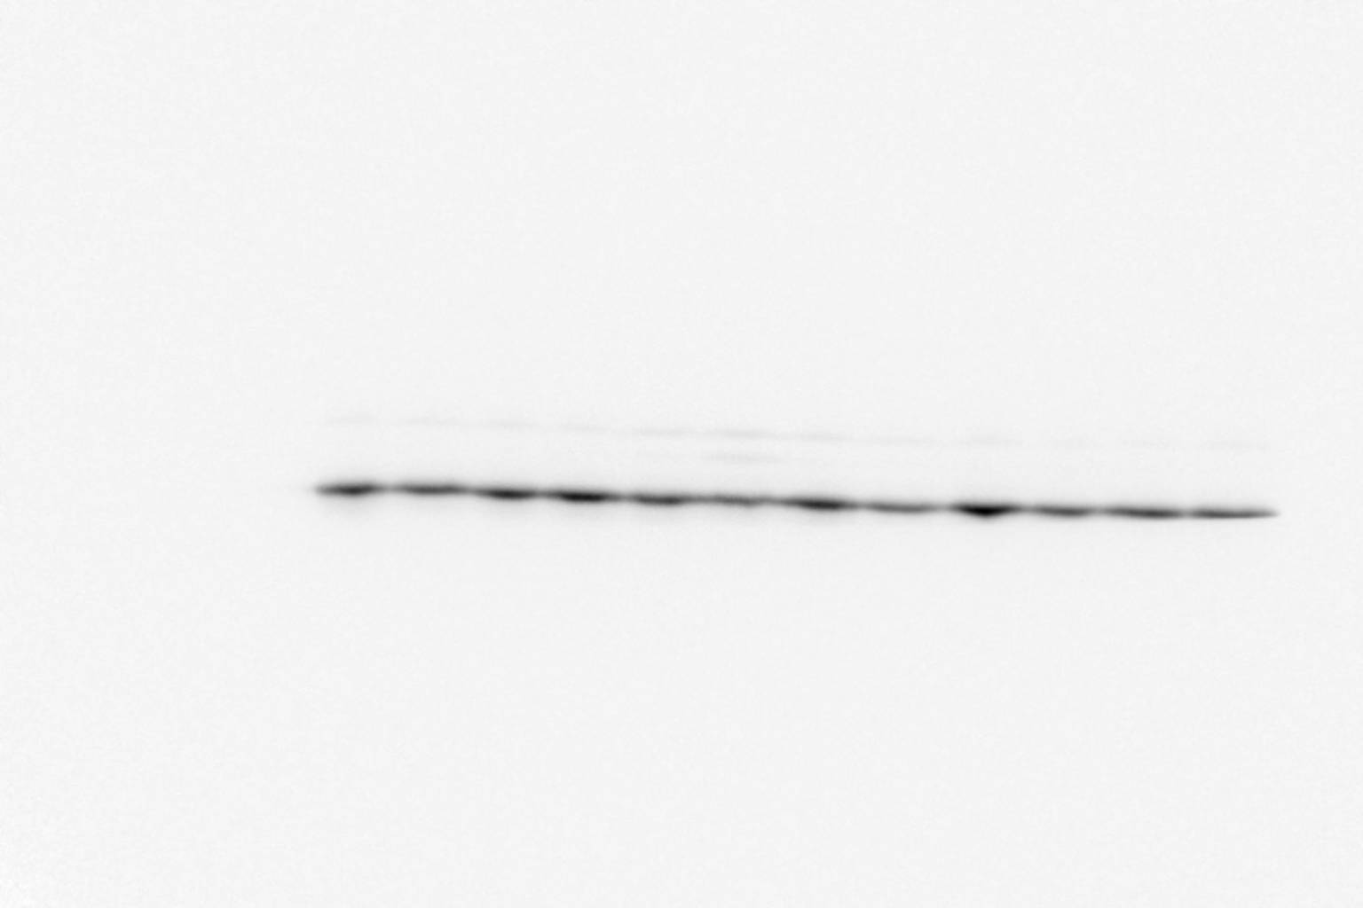

Fig2A GFP

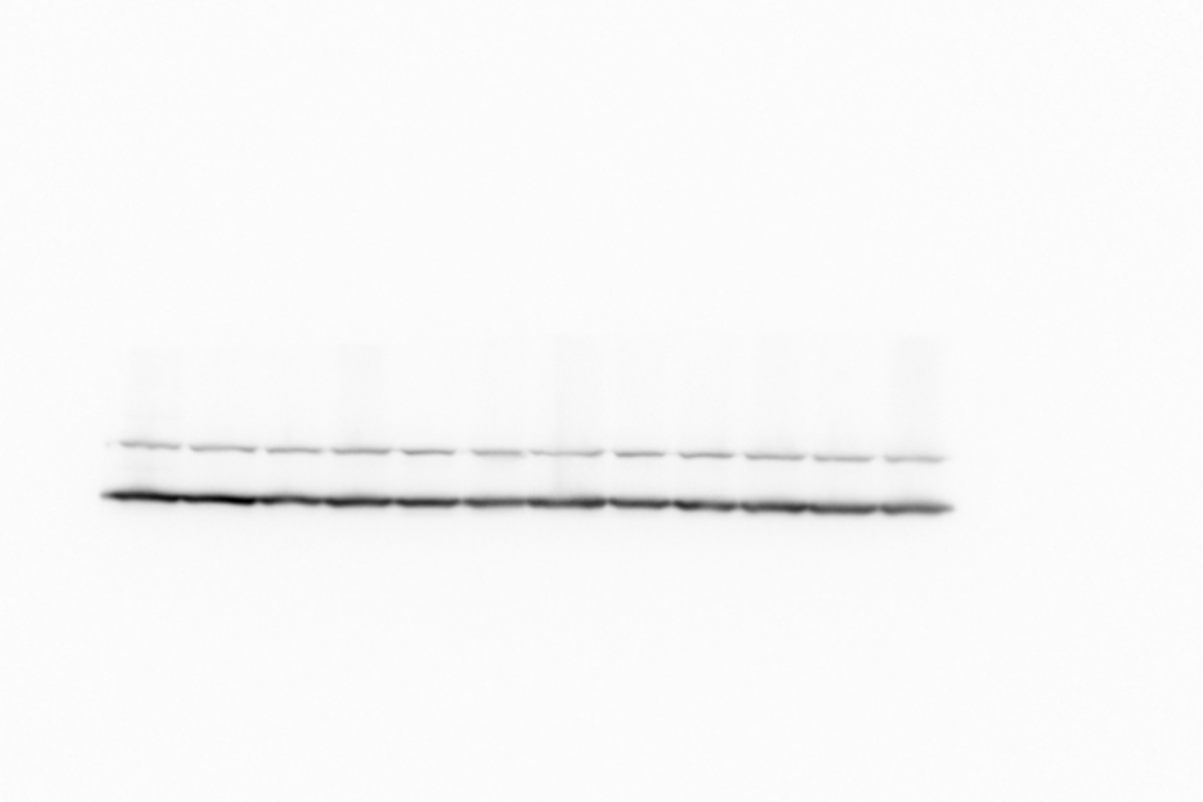

Fig2A Vinculin-Upper band

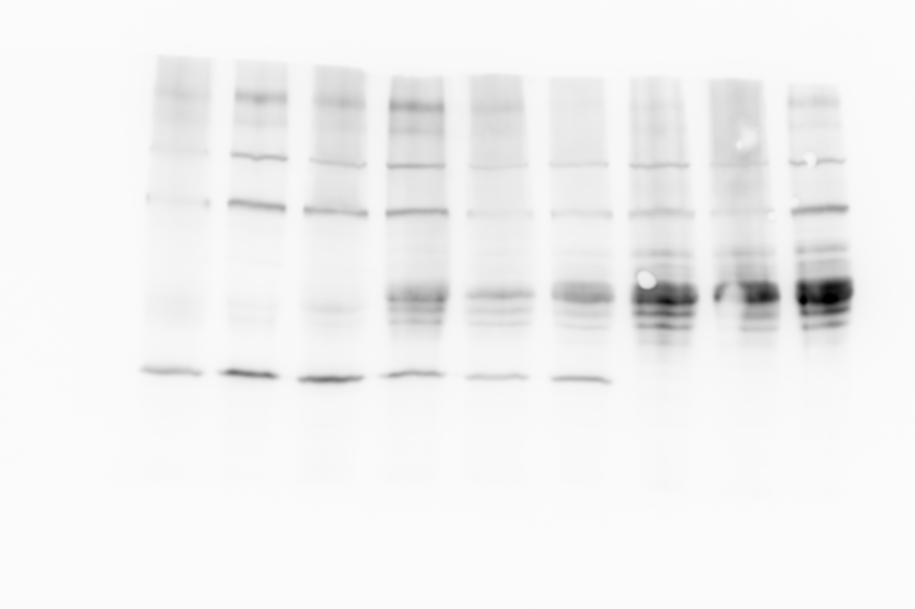

Supplementary Fig1.Tau protein (middle bands) and GFP (lower band)

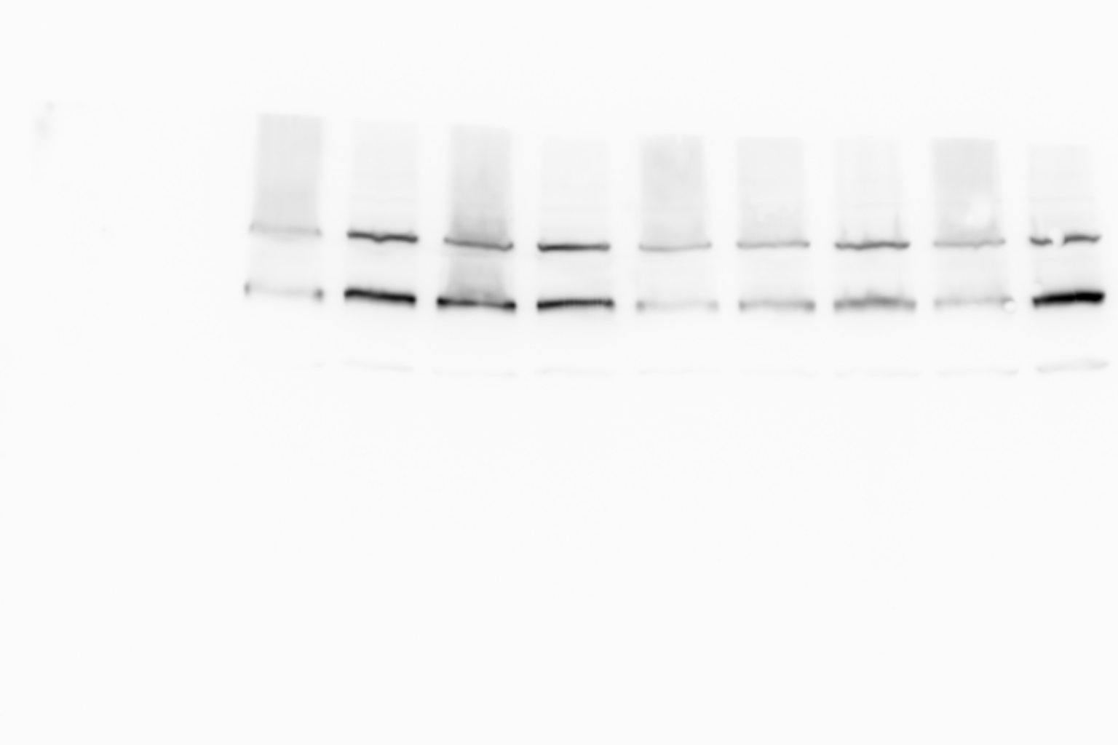

Supplementary Fig1. Vinculin ( Upper band)