Supplementary Material

Global Clinical Dementia Rating Score of 0.5 May Not Be an Accurate Criterion to Identify Individuals with Mild Cognitive Impairment

Supplementary Figure 1. Three-dimensional distance (TDD). Domain A is for activities of daily living (ADL), domain B is for the behavioral and psychological symptoms of dementia (BPSD), and domain C is for cognitive function. The scores per patient (Domain A, Domain B, Domain C) are plotted on a three-dimensional coordinate plane. Arrows show examples of the TDD. CDR, Clinical Dementia Rating.
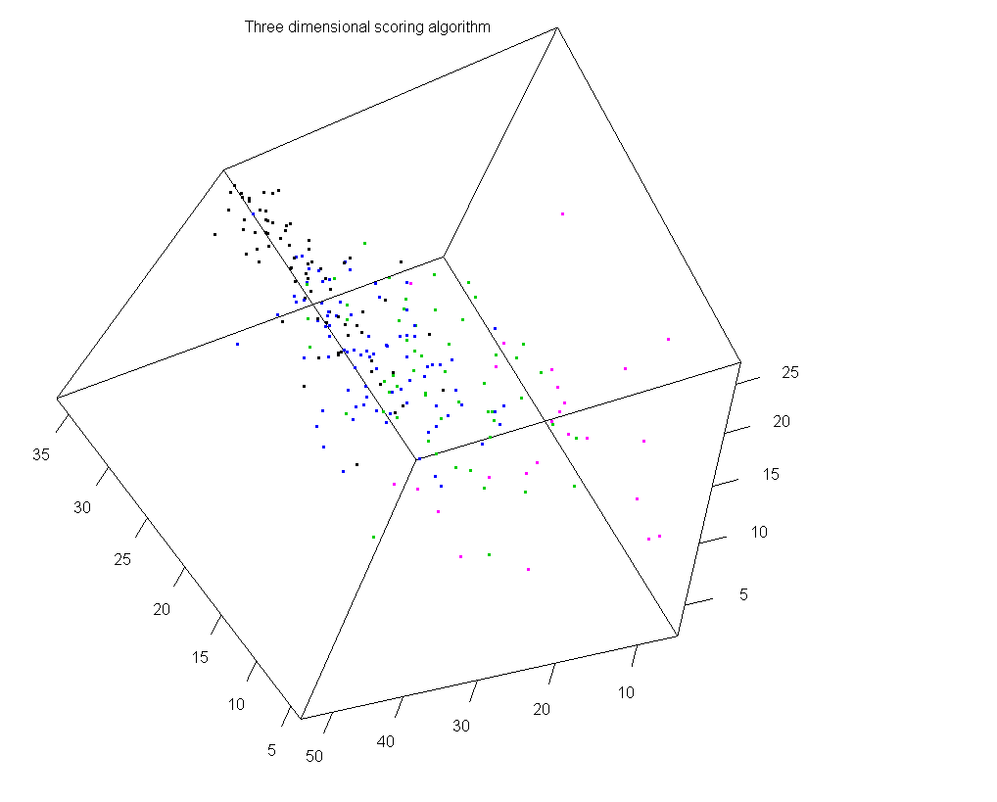
- CDR 3
- CDR 2
- CDR 1
- CDR 0/0.5
ADL
BPSD
Cognitive

This distance, referred to as the three-dimensional distance (TDD) score, is calculated as follows: TDD =$\sqrt{{(ADL score)}^{2}+{(BPSD score)}^{2}+ {(Cognitive function score)}^{2}}$,
where ADL, BPSD, and cognitive function scores are defined to increase with symptomatic improvement and to decrease towards 0 with symptom deterioration.
Supplementary Table 1. Items of the ABC-DS
Item | Domain | Question
Q1 | Activities of daily living | Daily activities: When the patient changes his/her clothes, how is he/she?
Q2 |  | Motivation: How willingly does the patient undertake activities of daily life?
Q3 |  | Communication: When the patient wants to communicate with others, how easily can he/she do it?
Q4 |  | Complex acts: When the patient wants to use electric appliances such as a TV or an air conditioner, how well can he/she do it?
Q5 | Cognitive function | Recent event memory: How well can the patient recall the place where he/she put his/her belongings?
Q6 |  | Recent event memory: How long can the patient remember daily happenings?
Q7 | Behavioral and psychological symptoms of dementia | Restlessness: When the patient is required to sit still, how is he/she?
Q8 |  | Irritability: When the patient feels something is unsatisfactory, how is he/she?
Q9 |  | Cooperativeness: When caregivers ask the patient something, how is he/she?
Q10 | Cognitive function | Medication: When the patient takes medication, how much help does he/she need?
Q11 | Activities of daily living | Meals: When the patient takes meals, how is he/she?
Q12 |  | Toilets: When the patient uses the toilet, how much help does he/she need?
Q13 | Cognitive function | Care-burden: How frequently should caregivers see to the patient?

