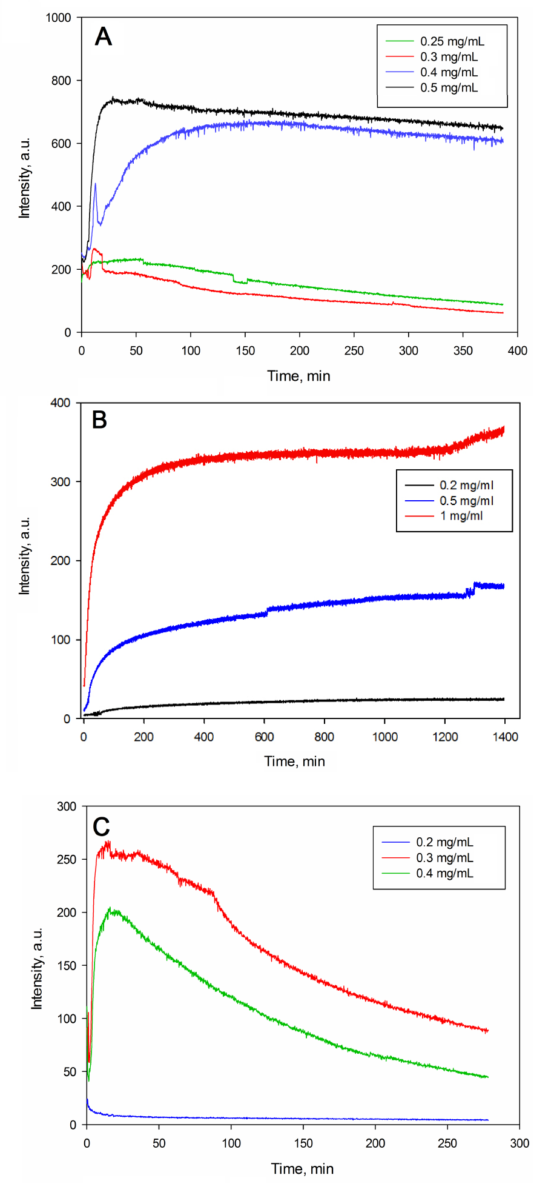
Supplementary Fig. 1. Data of thioflavin T fluorescence experiments with fragments of peptide Аβ₁₋₄₂: (A) Аβ₁₆₋₂₅, (B) Аβ₃₁₋₄₀, (C) Аβ₃₃₋₄₀. Preparations were obtained in 50 mM Tris-HCl with 5% of DMSO (used for better dissolving of fragments), pH 7.5, incubation at 37°C, various concentrations. Concentration of thioflavin T was 100 µM.

