Supplementary Material
S.1 CGAN generator layers
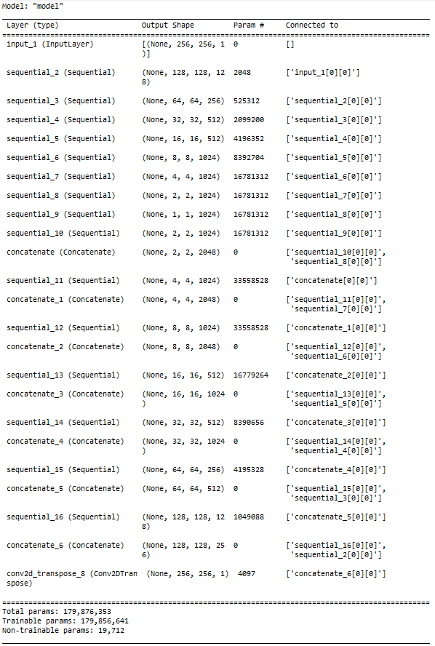
S.2 .CGAN discriminator layers

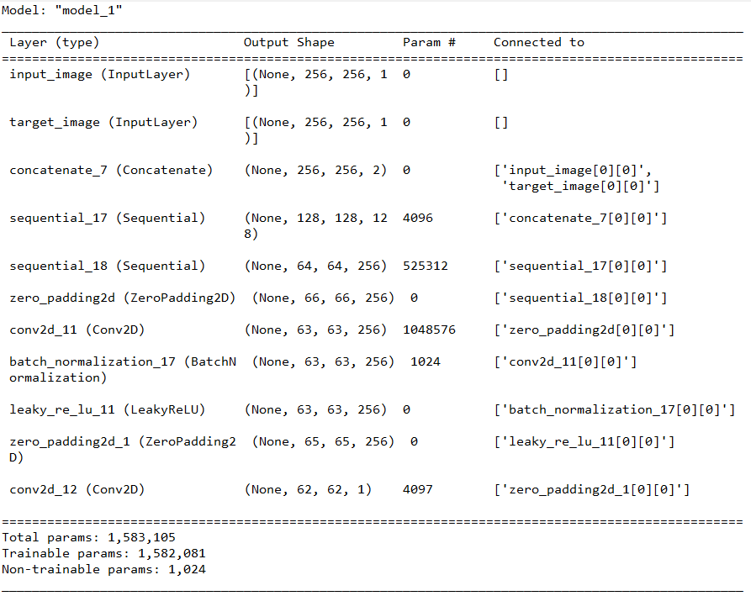
S.3 WGAN generator training layers
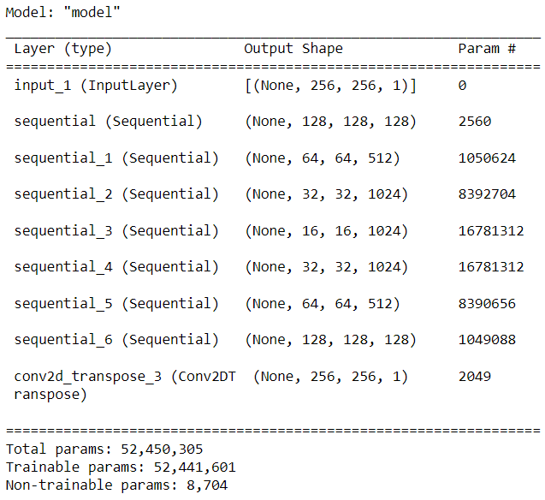
S.4 WGAN discriminator training layers

