5. Appendix
5.1 Supplemental Figures

(A)
(B)
(C)
Figure A1. Implementation of yeast budding patterns in the 2D-lattice model. Diagrams of the axial budding pattern in haploid cells (A), the bipolar budding pattern in diploid cells (B), and the unipolar budding pattern in nutrient limiting conditions (C) (see main text for details). In each of these diagrams, M denotes the original mother cell and D1 and D2 denote the second and third generation of buds, respectively. A black circle on the cell schematics indicates a bud scar (or a birth scar) on the cell. On the grids, a white arrow indicates the direction of the dividing cell’s bud scar, a white square an unoccupied lattice site, a light blue square a lattice site occupied by a dividing cell, a dark blue square a lattice site occupied by cells that are not dividing in the current timestep, and a grey square a possible lattice site into which a dividing cell can bud.
(A)
(B)
Figure A2. Diagram of the implementation of magnetic fields in the 2D lattice-based Monte Carlo framework. Angles are measured with respect to the line perpendicular to the applied magnetic field vector ($\overset{⃑}{B}$). (A) Left panel: A schematic of a magnetic field being applied along the y-axis (denoted by the thick black vertical arrow) biases budding in the 30º to 150º or -30º to -150º range (represented by the two grey segments in the large circle surrounding the mother cell, M). Right panel: Translating the magnetic field schematic to a 2D-lattice biases M towards budding into the lattice sites in the top and bottom rows (represented by the grey lattice sites). Similarly, a magnetic field applied along the x-axis would bias M towards budding into lattice sites in the columns to the left and right of M (not shown). (B) Left panel: A magnetic field applied along the diagonal (denoted by the thick black diagonal arrow) biases budding in the 30º to 150º or -30º to -150º range (represented by the grey segments of the large circle surrounding M). Right panel: Translating the magnetic field schematic to a 2D lattice biases M towards budding into the corner lattice sites (represented by the grey lattice sites).

Figure A3. Haploid colony area and P2A benchmarked against experimental data. Final experimental colony area (A) and perimeter to area (P2A) ratio (B) as a function of glucose concentration for the FLO11 and flo11$Δ$ Saccharomyces cerevisiae strains. Final simulated S. cerevisiae colony area (C) and P2A ratio (D) as a function of nutrient level using the 2D lattice-based Monte Carlo framework. Experimental data is from Ref. [2].

Figure A4. Haploid colony perimeter under different nutrient and magnetic field conditions. Violin plot of colony perimeters of colonies in various nutrient conditions, when exposed to magnetic fields (MFs) of different strengths and directions. The box and whisker plots within the violin plots denote the median, interquartile range (IQR), and $1.5×IQR$ (see Section 5.2 for more details). Simulations were repeated 800 times to generate the violin plots. Parameters were set as follows: rich-nutrient condition: START_NUTRS = 20, low-nutrient condition: START_NUTRS = 2; nSteps = 10; $p_{axial}=0.6$; no MFs: MF_STRENGTH = 0, weak MFs: MF_STRENGTH = 0.5, strong MFs: MF_STRENGTH = 1.

Figure A5. Haploid colony formation time under different nutrient and magnetic field conditions. Violin plots of the time to form a colony of 10,000 cells (starting from a single cell), when influenced by various magnetic field (MF) directions and strengths under low-nutrient and high-nutrient conditions. Parameters were set as follows: rich-nutrient condition: START_NUTRS = 20, low-nutrient condition: START_NUTRS = 2; nSteps = 10; $p_{axial}=0.6$; no MFs: MF_STRENGTH = 0, weak MFs: MF_STRENGTH = 0.5, strong MFs: MF_STRENGTH = 1.

Figure A6. Budding angle distributions benchmarked against experiment data. (A) No magnetic field: Experimental and simulated Saccharomyces cerevisiae budding angle population fractions in the absence of an applied magnetic field. (B) Magnetic field: Experimental and simulated Saccharomyces cerevisiae budding angle population fractions in the presence of an applied magnetic field. The applied magnetic field biases budding in the 30° to 150° and -30° to -150° (+/- 30° to +/-150°) range. Experimental data is from Ref. [13].

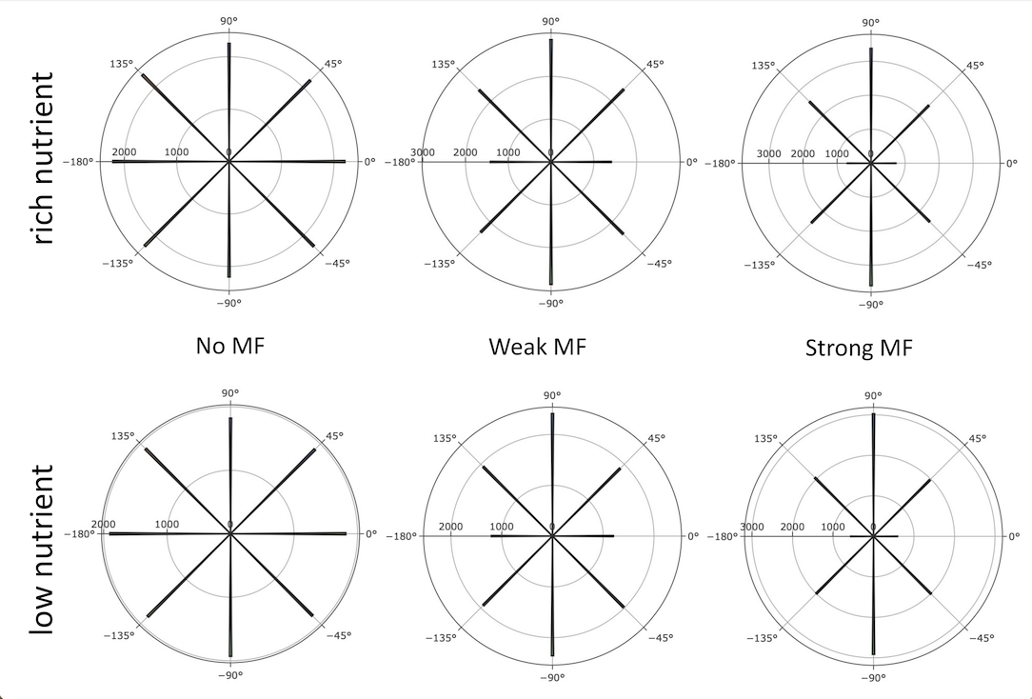
Figure A7. Budding angle distributions for diploid colonies under different nutrient conditions of magnetic field strengths. Plot of the frequency of the angle between the magnetic field direction and the mother-bud axis. The thick black lines radiating from the center represent the average number of cells that bud in a particular angle. Parameters were set as follows: rich-nutrient condition: START_NUTRS = 20, low-nutrient condition: START_NUTRS = 2; nSteps = 10; MAGNETIC_FIELD = [1 0]; no MFs: MF_STRENGTH = 0, weak MFs: MF_STRENGTH = 0.5, strong MFs: MF_STRENGTH = 1; UNIPOLAR_ON = false.

Figure A8. Number of cells in haploid colonies under different nutrient and magnetic field conditions. Violin plots of the number of cells in the yeast colony after 320,000 timesteps, when influenced by various magnetic field (MF) directions and strengths under rich-nutrient and low-nutrient conditions. Parameters were set as follows: rich-nutrient condition: START_NUTRS = 20, low-nutrient condition: START_NUTRS = 2; nSteps = 10; $p_{axial}=0.6$; no MFs: MF_STRENGTH = 0, weak MFs: MF_STRENGTH = 0.5, strong MFs: MF_STRENGTH = 1.
Figure A9. Diploid colony area under different nutrient and magnetic field conditions. Violin plots of yeast colony area after 320,000 timesteps, when influenced by various magnetic field (MF) directions and strengths under rich-nutrient and low-nutrient conditions. Parameters were set as follows: rich-nutrient condition: START_NUTRS = 20, low-nutrient condition: START_NUTRS = 2; nSteps = 10; $p_{axial}=0$; no MFs: MF_STRENGTH = 0, weak MFs: MF_STRENGTH = 0.5, strong MFs: MF_STRENGTH = 1.

Figure A10. Diploid colony formation time under different nutrient and magnetic field conditions. Violin plots of the time to form a colony of 10,000 cells (starting from a single cell), when influenced by various magnetic field (MF) directions and strengths under low-nutrient and high-nutrient conditions. Parameters were set as follows: rich-nutrient condition: START_NUTRS = 20, low-nutrient condition: START_NUTRS = 2; nSteps = 10; $p_{axial}=0$; no MFs: MF_STRENGTH = 0, weak MFs: MF_STRENGTH = 0.5, strong MFs: MF_STRENGTH = 1.

Figure A11. Diploid colony perimeter under different nutrient and magnetic field conditions. Violin plot of colony perimeters of colonies in various nutrient conditions, when exposed to magnetic fields (MFs) of different strengths and directions. Parameters were set as follows: rich-nutrient condition: START_NUTRS = 20, low-nutrient condition: START_NUTRS = 2; nSteps = 10; $p_{axial}=0$; no MFs: MF_STRENGTH = 0, weak MFs: MF_STRENGTH = 0.5, strong MFs: MF_STRENGTH = 1.
Figure A12. Diploid colony roundness under different nutrient and magnetic field conditions. Violin plots of colony roundness under different nutrient conditions and different magnetic field (MF) directions and strengths. Parameters were set as follows: rich-nutrient condition: START_NUTRS = 20, low-nutrient condition: START_NUTRS = 2; nSteps = 10; $p_{axial}=0$; no MFs: MF_STRENGTH = 0, weak MFs: MF_STRENGTH = 0.5, strong MFs: MF_STRENGTH = 1.
Figure A13. Diploid colony solidity under different nutrient and magnetic field conditions. Violin plot of colony solidity in various nutrient conditions while exposed to magnetic fields (MFs) of different strengths and directions. Parameters were set as follows: rich-nutrient condition: START_NUTRS = 20, low-nutrient condition: START_NUTRS = 2; nSteps = 10; $p_{axial}=0$; no MFs: MF_STRENGTH = 0, weak MFs: MF_STRENGTH = 0.5, strong MFs: MF_STRENGTH = 1.

Figure A14. Schematic of convex quantities. (A) Depicted is a non-convex shape (outlined in red), which is a shape that contains pairs of points where the line segment connecting them does not lie entirely within the shape (an example is shown in green). The convex hull (represented by a black line) of any shape is the smallest convex shape containing it. The convex area (sum of the light blue and dark blue regions) is the area of the convex hull. The convex perimeter is the perimeter of the convex hull (black line). (B) Depicted is a convex shape (outlined in red), which is a shape where the line segment between any two points in the shape lies within the shape (an example is shown in green). For a convex shape, the shape and its convex hull are the same, and the area and perimeter follow the conventional definitions.

Figure A15. Violin plot schematics. (A) A symmetric violin plot displaying the full distribution of the data and summary statistics for a single experimental condition. The curve represents the full distribution of data for a particular quantity. The box and whisker plot (box plot) shows the following summary statistics: median, interquartile range (IQR: box from the first to the third quartile), median (vertical line through the box), and $±1.5×IQR$ (lines or “whiskers” emanating from each quartile). Each side of this conventional violin plot is a mirror image of the other. (B) A schematic of an asymmetric violin plot displaying the full distribution of the data and summary statistics for two experimental conditions. In this case, each side of the violin plot corresponds to a different experimental condition (condition 1 is shown in purple and condition 2 is shown is green).

