Supplemental Information

Supplement 1
Heavy chain sequence alignment of mouse anti-TAC with the human mAb EU, (providing the FR regions for humanization) and the humanized variant Daclizumab. The first lanes (black arrows) indicate different nomenclatures for complementary determining regions defined by IMGT, Kabat and Queen. Sequence related amino acid residues are indicated in green defining the canonical CDR structure class, red arrows show murine backmutations based on investigation of the crystal structure, orange arrows indicate unusual EU residues and blue arrows indicate deviations from the human IGHV1-46*01 germline.
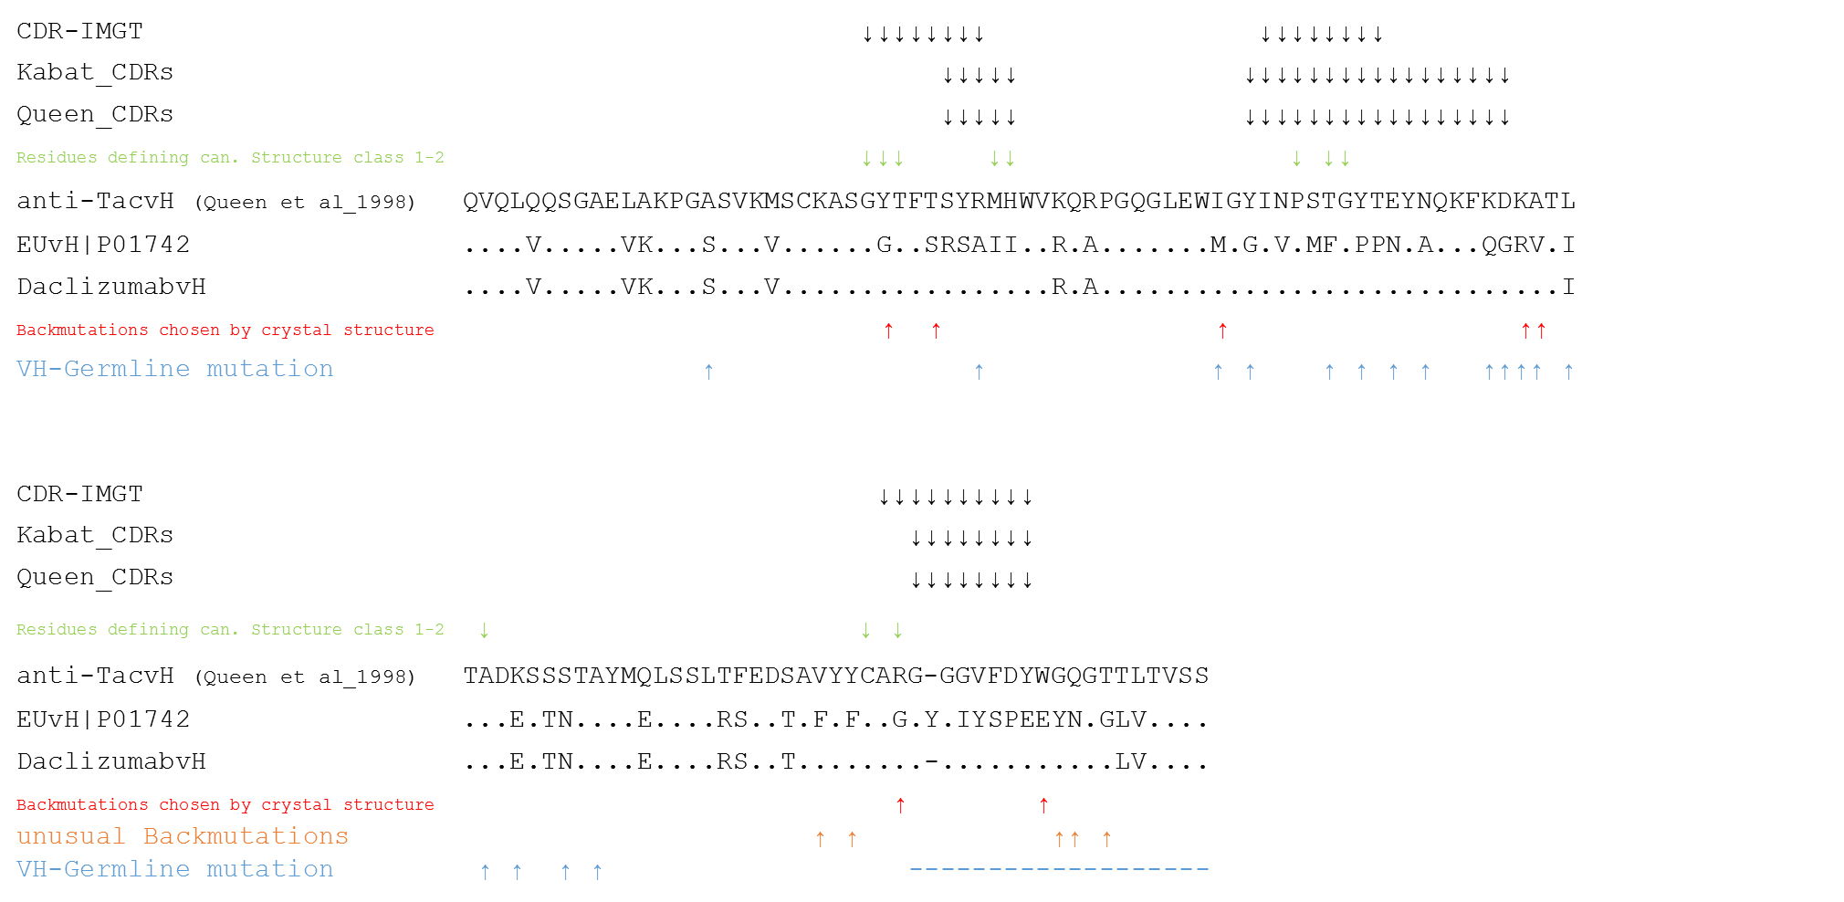

Supplement 2
Germinality of selected human anti-HIV antibodies indicates that none of the neutralizing human mAbs would reach the 85% identity with the nearest related human germline for being categorized as "humanized". Only the non-neutralizing mAb 3D6 is highly homologous to the germline.
Anti-HIV mAb | Germline VH | Identity | Germline VL | Identity
3D6 | IGHV3-9*03 | 95.6% | IGKV1-5*03 | 97.9%
4B3 | IGHV1-69*10 | 82.5% | IGLV6-57*01 | 89.8%
2F5 | IGHV2-5*01 | 85.0% | IGKV1-13*02 | 85.3%
2G12 | IGHV3-21*01 | 78.9% | IGKV1-5*03 | 87.3%
PG9 | IGHV3-30*02 | 81.2% | IGLV2-14*01 | 87.5%
PG16 | IGHV3-30*03 | 78.6% | IGLV2-14*01 | 80.4%

