**Supplementary Table S1. GO/KEGG enrichment analysis results of DEGs**

**GO**



**KEGG**

|  |  |  |  |  |
| --- | --- | --- | --- | --- |
| ID | Description | pvalue | p.adjust | Count |
| hsa03250 | Viral life cycle - HIV-1 | 0.005492 | 0.005492 | 8 |
| hsa01232 | Nucleotide metabolism | 0.010891 | 0.010891 | 9 |
| hsa03050 | Proteasome | 0.013656 | 0.013656 | 6 |
| hsa05012 | Parkinson disease | 0.039753 | 0.039753 | 18 |
| hsa03010 | Ribosome | 0.041021 | 0.041021 | 12 |
| hsa03022 | Basal transcription factors | 0.04369 | 0.04369 | 5 |
| hsa04550 | Signaling pathways regulating pluripotency of stem cells | 0.045499 | 0.045499 | 11 |
| hsa00230 | Purine metabolism | 0.050393 | 0.050393 | 10 |
| hsa00310 | Lysine degradation | 0.05404 | 0.05404 | 6 |
| hsa00280 | Valine, leucine and isoleucine degradation | 0.055208 | 0.055208 | 5 |
| hsa00330 | Arginine and proline metabolism | 0.068318 | 0.068318 | 5 |
| hsa05020 | Prion disease | 0.083227 | 0.083227 | 17 |
| hsa04659 | Th17 cell differentiation | 0.095517 | 0.095517 | 8 |
| hsa04931 | Insulin resistance | 0.095517 | 0.095517 | 8 |
| hsa05169 | Epstein-Barr virus infection | 0.098738 | 0.098738 | 13 |
| hsa04072 | Phospholipase D signaling pathway | 0.107854 | 0.107854 | 10 |
| hsa04966 | Collecting duct acid secretion | 0.109447 | 0.109447 | 3 |
| hsa05016 | Huntington disease | 0.114173 | 0.114173 | 18 |
| hsa00650 | Butanoate metabolism | 0.118854 | 0.118854 | 3 |
| hsa00140 | Steroid hormone biosynthesis | 0.123107 | 0.123107 | 5 |
| hsa04910 | Insulin signaling pathway | 0.139031 | 0.139031 | 9 |
| hsa05135 | Yersinia infection | 0.139031 | 0.139031 | 9 |
| hsa04662 | B cell receptor signaling pathway | 0.14347 | 0.14347 | 6 |
| hsa00620 | Pyruvate metabolism | 0.144524 | 0.144524 | 4 |
| hsa04973 | Carbohydrate digestion and absorption | 0.144524 | 0.144524 | 4 |
| hsa00410 | beta-Alanine metabolism | 0.148728 | 0.148728 | 3 |
| hsa04927 | Cortisol synthesis and secretion | 0.149391 | 0.149391 | 5 |
| hsa04215 | Apoptosis - multiple species | 0.159178 | 0.159178 | 3 |
| hsa04120 | Ubiquitin mediated proteolysis | 0.161808 | 0.161808 | 9 |

**Supplementary Table S2. GSEA results for gene expression profile**

**KEGG for GSEA**

|  |  |  |  |  |  |  |
| --- | --- | --- | --- | --- | --- | --- |
| ID | Description | setSize | enrichmentScore | NES | pvalue | p.adjust |
| hsa03010 | Ribosome | 154 | -0.58842 | -2.41774 | 1.00E-10 | 1.11E-08 |
| hsa04380 | Osteoclast differentiation | 126 | -0.57628 | -2.29657 | 1.00E-10 | 1.11E-08 |
| hsa05168 | Herpes simplex virus 1 infection | 493 | -0.43095 | -2.03477 | 1.00E-10 | 1.11E-08 |
| hsa05171 | Coronavirus disease - COVID-19 | 231 | -0.45854 | -1.98937 | 1.63E-09 | 1.36E-07 |
| hsa04020 | Calcium signaling pathway | 239 | 0.459978 | 1.978501 | 5.56E-09 | 3.71E-07 |
| hsa05323 | Rheumatoid arthritis | 89 | -0.58565 | -2.23167 | 6.73E-09 | 3.74E-07 |
| hsa04145 | Phagosome | 149 | -0.49909 | -2.04686 | 1.43E-08 | 6.81E-07 |
| hsa04640 | Hematopoietic cell lineage | 96 | -0.56277 | -2.17249 | 2.47E-08 | 1.03E-06 |
| hsa05164 | Influenza A | 169 | -0.47099 | -1.95767 | 5.64E-08 | 2.09E-06 |
| hsa05169 | Epstein-Barr virus infection | 199 | -0.44051 | -1.88097 | 1.80E-07 | 6.00E-06 |
| hsa05152 | Tuberculosis | 177 | -0.45106 | -1.88632 | 2.89E-07 | 8.77E-06 |
| hsa04261 | Adrenergic signaling in cardiomyocytes | 149 | 0.483313 | 1.952666 | 5.22E-07 | 1.38E-05 |
| hsa00190 | Oxidative phosphorylation | 121 | -0.50149 | -1.9876 | 5.36E-07 | 1.38E-05 |
| hsa04621 | NOD-like receptor signaling pathway | 183 | -0.44036 | -1.85231 | 5.78E-07 | 1.38E-05 |
| hsa04022 | cGMP-PKG signaling pathway | 166 | 0.456893 | 1.878047 | 1.29E-06 | 2.87E-05 |
| hsa05410 | Hypertrophic cardiomyopathy | 90 | 0.538616 | 2.028763 | 2.79E-06 | 5.82E-05 |
| hsa04260 | Cardiac muscle contraction | 83 | 0.54454 | 2.016812 | 3.13E-06 | 6.14E-05 |
| hsa05140 | Leishmaniasis | 74 | -0.54676 | -2.01473 | 3.73E-06 | 6.93E-05 |
| hsa05414 | Dilated cardiomyopathy | 95 | 0.522898 | 1.958134 | 5.86E-06 | 9.92E-05 |

**GO for GSEA**

|  |  |  |  |  |  |  |
| --- | --- | --- | --- | --- | --- | --- |
| ONTOLOGY | ID | Description | setSize | NES | pvalue | p.adjust |
| BP | GO:0002283 | neutrophil activation involved in immune response | 487 | -1.93033 | 1.00E-10 | 1.43E-08 |
| BP | GO:0002446 | neutrophil mediated immunity | 498 | -1.95091 | 1.00E-10 | 1.43E-08 |
| BP | GO:0002478 | antigen processing and presentation of exogenous peptide antigen | 175 | -2.16118 | 1.00E-10 | 1.43E-08 |
| BP | GO:0002831 | regulation of response to biotic stimulus | 415 | -1.99301 | 1.00E-10 | 1.43E-08 |
| BP | GO:0002833 | positive regulation of response to biotic stimulus | 254 | -2.09492 | 1.00E-10 | 1.43E-08 |
| BP | GO:0003002 | regionalization | 326 | 1.967172 | 1.00E-10 | 1.43E-08 |
| BP | GO:0003012 | muscle system process | 441 | 2.470655 | 1.00E-10 | 1.43E-08 |
| BP | GO:0003015 | heart process | 284 | 2.040949 | 1.00E-10 | 1.43E-08 |
| MF | GO:0003735 | structural constituent of ribosome | 166 | -2.3826 | 1.00E-10 | 1.43E-08 |
| BP | GO:0006936 | muscle contraction | 348 | 2.527414 | 1.00E-10 | 1.43E-08 |
| BP | GO:0006941 | striated muscle contraction | 174 | 2.384606 | 1.00E-10 | 1.43E-08 |
| BP | GO:0007389 | pattern specification process | 425 | 1.925059 | 1.00E-10 | 1.43E-08 |
| BP | GO:0007517 | muscle organ development | 315 | 2.363793 | 1.00E-10 | 1.43E-08 |
| BP | GO:0008016 | regulation of heart contraction | 240 | 2.123331 | 1.00E-10 | 1.43E-08 |
| BP | GO:0009615 | response to virus | 354 | -2.04833 | 1.00E-10 | 1.43E-08 |
| BP | GO:0010927 | cellular component assembly involved in morphogenesis | 100 | 2.356226 | 1.00E-10 | 1.43E-08 |
| BP | GO:0014706 | striated muscle tissue development | 347 | 2.409107 | 1.00E-10 | 1.43E-08 |
| CC | GO:0016528 | sarcoplasm | 79 | 2.478422 | 1.00E-10 | 1.43E-08 |
| CC | GO:0016529 | sarcoplasmic reticulum | 70 | 2.428981 | 1.00E-10 | 1.43E-08 |

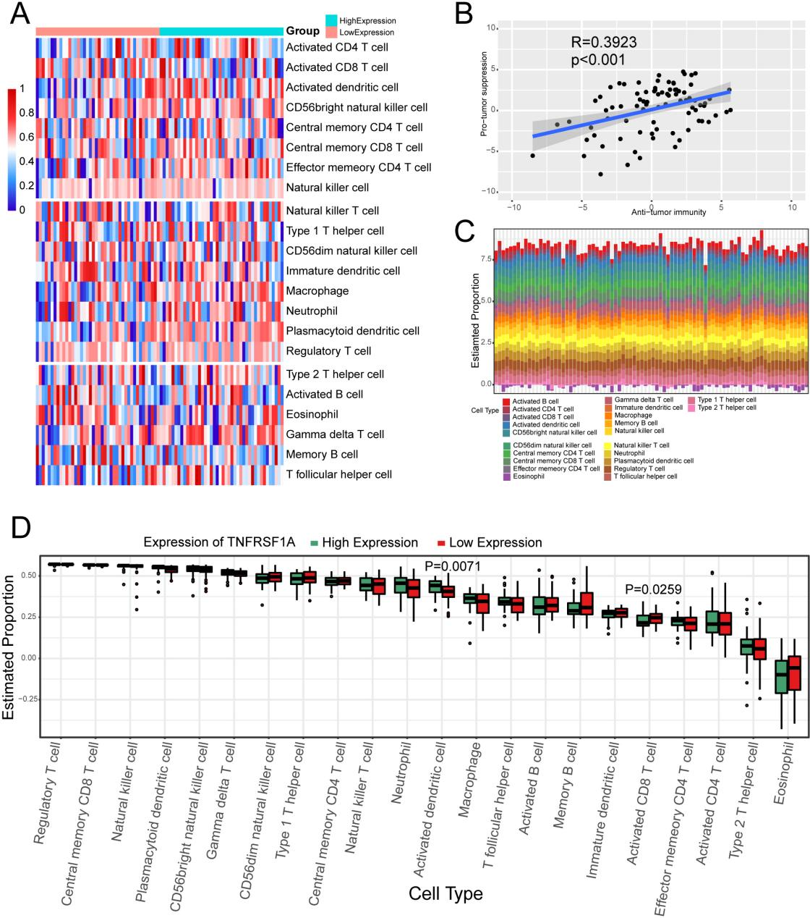Figure S1 GO/KEGG enrichment analysis of DEGs in different TNFRSF1A expression groups. (a) Bar plot of GO terms; the x-axis is -log10 (P-value); the y-axis is the enriched GO terms. (b) GO enrichment pathway network diagram. Important enrichment pathways are presented as nodes, and the interrelationships are connected by gray lines. (c) Heat map of GO enrichment pathways. The horizontal axis indicates the genes involved; the vertical axis is the enriched pathway; the black color indicates that the enrichment result is ``yes'', white is ``no''. (d) Bar plot of KEGG pathways; the x-axis is -log10 (P-value); y-axis is the enriched pathway. The bars are colored to indicate the corrected P-value.

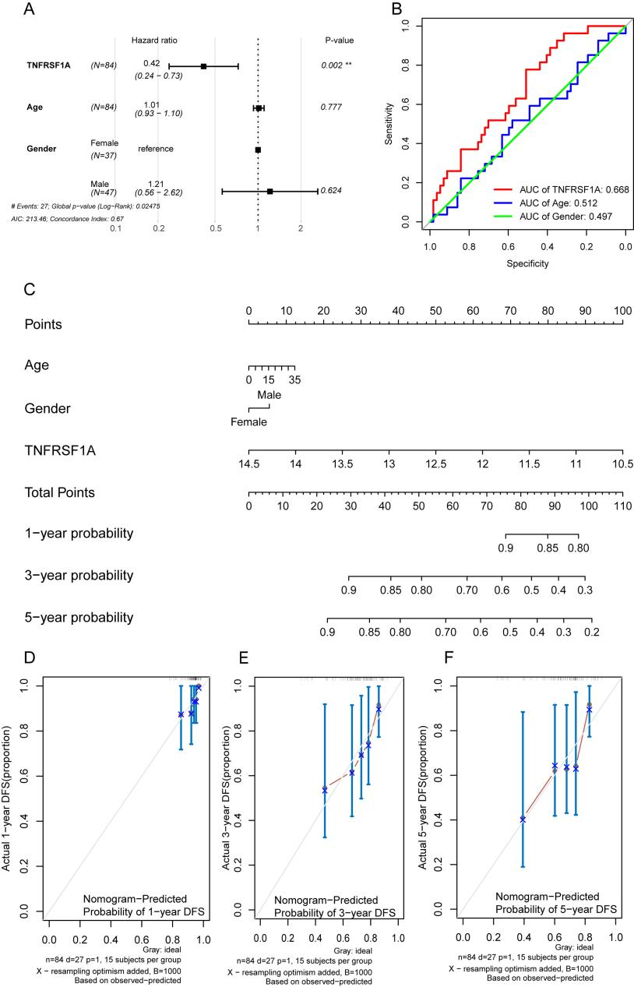Figure S2 GSEA for the TNFRSF1A high- and low-expression groups. (a--c) The top three GSEA results for the GO database P-value in the TARGET-OS cohort are shown, respectively. (d--f) The bottom three GSEA results for the KEGG database P-value in the TARGET-OS cohort are shown, respectively. The x-axis is the rank of the gene in the list of DEGs, with upregulation > 0 and downregulation < 0. The upper y-axis is the enrichment score, and the lower y-axis is the logFC value, with each graph representing a pathway.