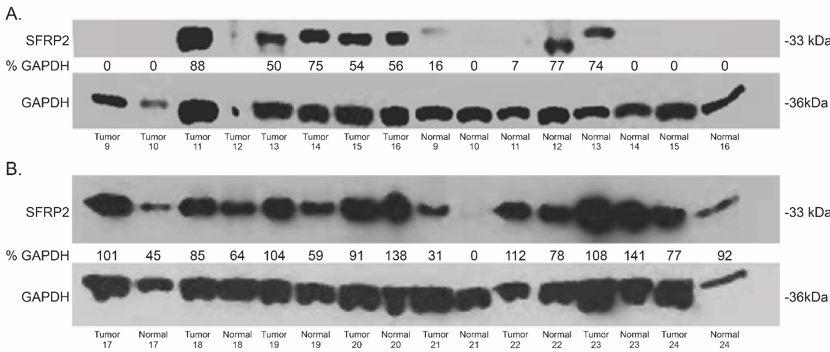
Supplemental Fig. 1: SFRP2 protein expression is increased in pancreatic cancer. Additional western blots showing the levels of SFRP2 protein in tumor and matching normal adjacent tissue samples tested to generate the results displayed in figure 2A. GAPDH was used as a loading control.

