Supplement to:
“Modulation of Distinct Intrinsic Resting State Brain Networks by Acute Exercise Bouts of Differing Intensity”

Subgroup analysis including HR as covariate of no interest
Due to artifacts in recording HR (heart rate) during the resting state functional magnetic resonance imaging (rs-fMRI) scan, we needed to exclude N=4 subjects for investigating the interaction effects between time (pre and post) and condition (‘low’ and ‘high’), and N=2 subjects for each exercise intervention resulting in a sample size of N=20 to compare pre to post ‘low’ exercise intensity and pre to post ‘high’ exercise intensity. Including the HR as covariate of no interest in our analysis lead to almost the same results, which we found for the whole group analysis without HR:

Right Affect and Reward Network
In the RARN we found no significant time x condition interaction in rs-FC anymore, although a very strong trend was revealed. Thresholding the data with 0.1 revealed an increase in FC in the right insula (p=0.051) and right putamen (p=0.056) in the ‘high’ condition and a decrease in the ‘low’ condition. (Figure S1-A, Table S1).

Right Fronto Parietal Network
Results of the rs-FC analysis in the RFPN indicated a significant time x condition interaction in the right middle frontal gyrus (Figure S1-B, Table S1), driven by a significant increase in FC after ‘low’ exercise intensity in the right middle frontal gyrus (MFG) and the left cerebellar crus 2 (Figure S2-D, Table S2).

Sensorimotor Network
The rs-FC analysis in the SMN revealed a significant time x condition interaction in the postcentral gyrus and precuneus (Figure S1-C, Table S1). Comparing pre versus post ‘high’ exercise condition showed a significant decrease in rs-FC also in the postcentral gyrus and MCC (Figure S2-F, Table S2).

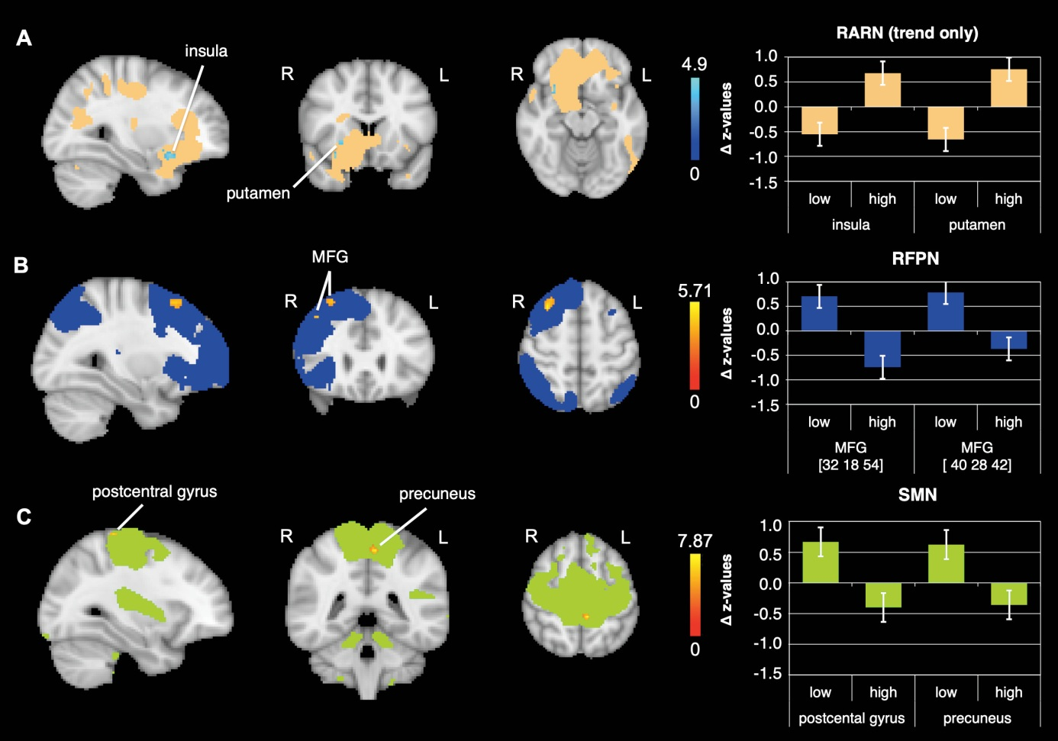
Figure S1: FC changes observed significantly different between conditions (‘low’ and ‘high’ intensity) when including HR as covariate of no interest in our analyses. Significant clusters in the interaction of the: A) RARN in the right anterior insula and right putamen (trend only, results are presented at p=0.1); B) RFPN in the right middle frontal gyrus (MFG); C) SMN in the left postcentral gyrus and precuneus; data shown is corrected for p<0.05, after multiple comparison correction using TFCE approach; z-values were normalized by dividing them by SD; For enhancing the contrast between the activation clusters and the RSN masks, we chose either blue or red for the activation clusters. The colors do not indicate increases or decreases. R = right; L = left.

brain region | side | k | x | y | z | p-value (tfce)
RARN – ‘high’ > ‘low’
insula | R | 15 | 30 | 14 | -14 | 0.051**
putamen | R | 14 | 26 | 14 | -2 | 0.056**
RFPN - ‘low’ > ‘high’
middle frontal gyrus | R | 78 | 32 | 18 | 54 | 0.017
middle frontal gyrus | R | 10 | 40 | 28 | 42 | 0.039
SMN – ‘low’ > ‘high’
precuneus | L | 30 | -6 | -40 | 54 | 0.007
postcentral gyrus | L | 7* | -30 | -36 | 70 | 0.029
Table S1: Brain regions observed significantly different between conditions (‘low’ and ‘high’ intensity) when including HR as covariate of no interest in our analyses. Coordinates presented are in MNI space; k = cluster size; N = 18; *small cluster size, needs to be treated with caution; **represents a very strong trend.

Executive Control Network
The ECN revealed no significant time x condition interaction in rs-FC. However, there was a significant increase in FC from pre to post ‘low’ exercise condition in the middle frontal gyrus (Figure S2-A, Table S2).

Dorsal Attention Network
The DAN revealed no significant time x condition interaction in rs-FC, although we could detect a trend (p=0.07). However, there was a significant decrease in FC from pre to post ‘high’ exercise condition in the postcentral gyrus (Figure S2-B, Table S2).

Left Affect and Reward Network
The LARN did not reveal a significant time x condition interaction in rs-FC. However, there was a significant increase in FC from pre to post ‘high’ exercise condition in the left cerebellar lobule 6 (Figure S2-C, Table S2).

Left Fronto Parietal Network
The LFPN did not reveal a significant time x condition interaction, but a significant increase in rs-FC from pre to post ‘low’ exercise condition in the inferior frontal gyrus (IFG) (Figure S2-D, Table S2).

Other networks
We did not detect any further significant changes in FC in the other examined RSN. However, we could detect a statistical trend in the Salience network in form of an increase from pre to post ‘low’ exercise condition (p=0.09).

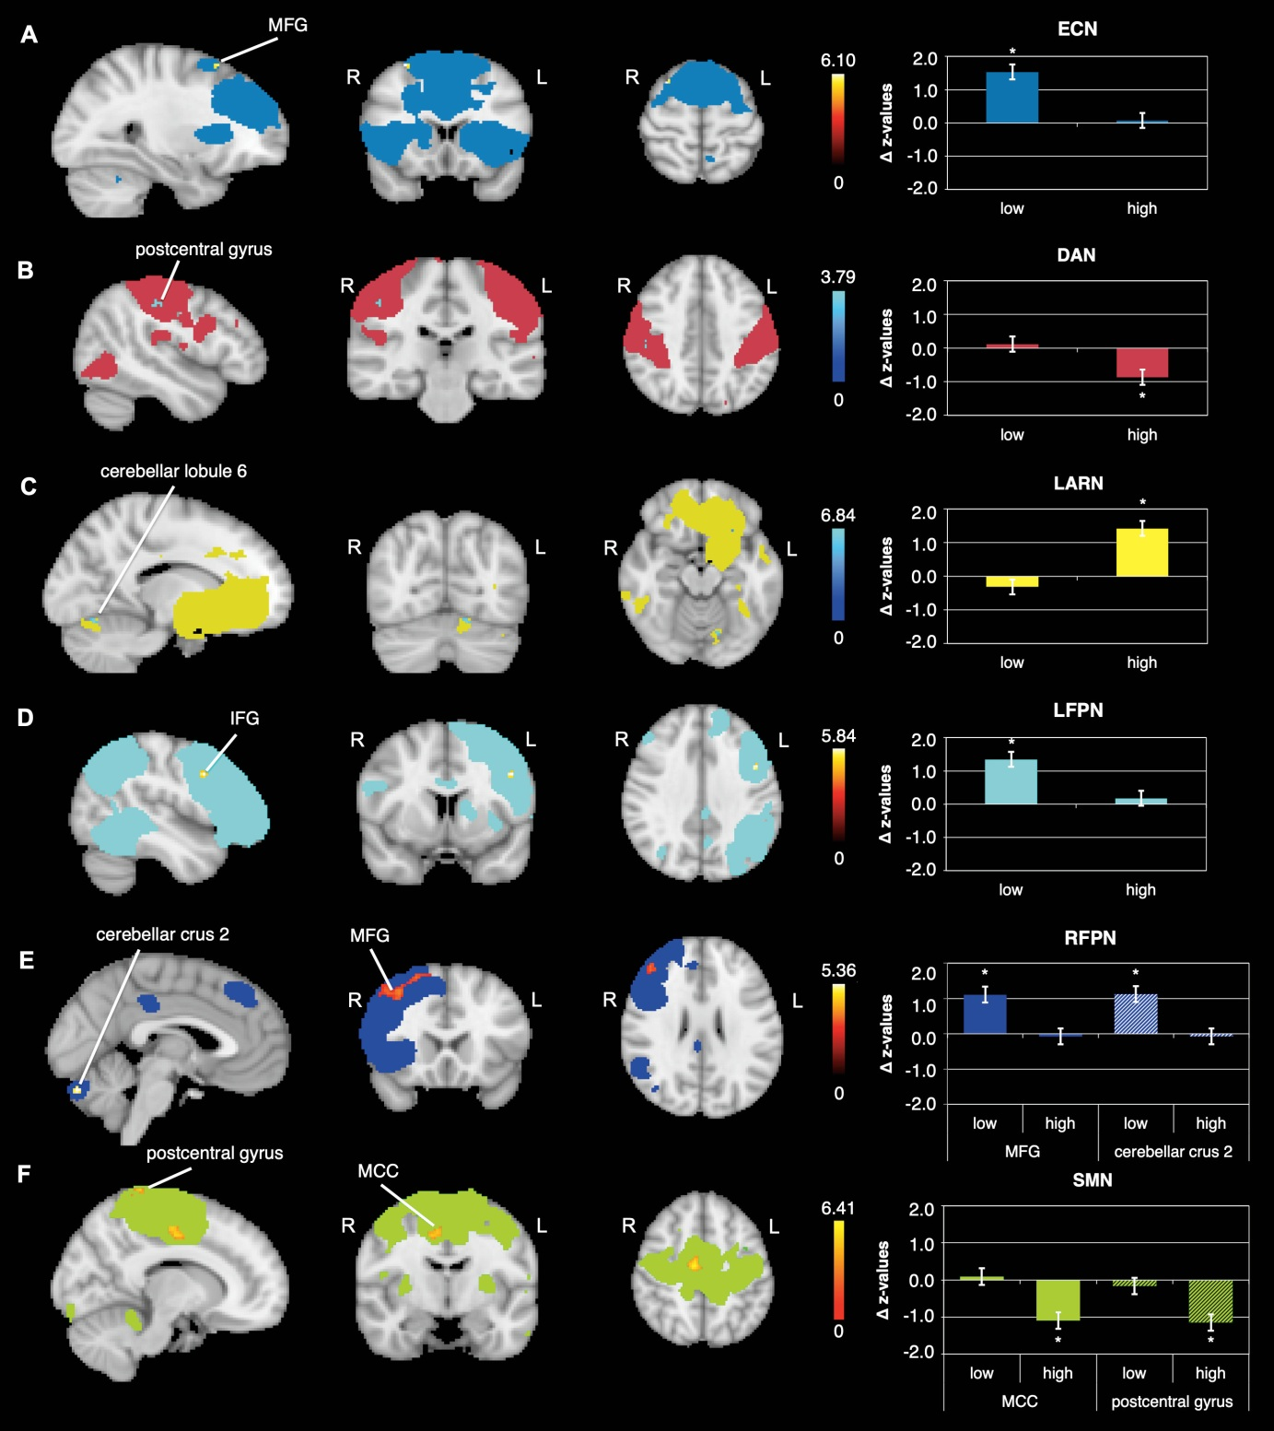
Figure S2: Differential effects in rs-FC from pre to post within exercise condition when including HR as covariate of no interest. Rs-FC changes in the: A) ECN within the ‘low’ condition (post>pre) in the middle frontal gyrus (MFG), B) DAN within the ‘high’ condition (pre>post) in the postcentral gyrus, C) LARN within the ‘high’ condition (post>pre) in the cerebellar lobule 6, D) LFPN within the ‘low’ condition (post>pre) in the inferior frontal gyrus (IFG), E) RFPN within the ‘low’ condition (post>pre) in the MFG and cerebellar crus 2, F) SMN within the ‘high’ condition (pre>post) in the middle cingulate cortex (MCC) and postcentral gyrus; data shown is corrected for p<0.05, after multiple comparison correction using TFCE approach; z-values were normalized by dividing them by SD; For enhancing the contrast between the activation clusters and the RSN masks, we chose either blue or red for the activation clusters. The colors do not indicate increases or decreases. N=20; R = right; L = left.

brain region | side | k | x | y | z | p-value (tfce)
ECN – ‘low’ post>pre
middle frontal gyrus | R | 4* | 30 | 16 | 60 | 0.036
DAN – ‘high’ pre>post
postcentral gyrus | R | 8* | 48 | -22 | 44 | 0.048
LARN – ‘high’ post>pre
cerebellar lobule 6 | L | 8* | -14 | -70 | -18 | 0.012
LFPN – ‘low’ post>pre
inferior frontal gyrus | L | 12 | -46 | 8 | 34 | 0.025
RFPN – ‘low’ post>pre
middle frontal gyrus | R | 681 | 50 | 24 | 36 | 0.008
cerebellar crus 2 | L | 8* | -2 | -82 | -28 | 0.039
SMN – ‘high’ pre>post
middle cingulate cortex | R | 109 | 8 | -12 | 46 | 0.006
postcentral gyrus | R | 76 | 16 | -42 | 74 | 0.020
Table S2: Brain regions observed significantly different between pre and post within each exercise condition when including HR as covariate of no interest in our analyses. Coordinates presented are in MNI space; k = cluster size; N = 20; *small cluster size, needs to be treated with caution.

Additional analysis including nuisance regression (WM and CSF)
As regressing out WM and CSF is routinely performed in standard preprocessing pipelines, we additionally show the data with nuisance regression (WM and CSF) (N=22). Although, we loose significances in some of our results (DAN and ECN), which might be due to the loss of degrees of freedom by inserting WM and CSF in the design, the results of this analysis further support our results.

Right Affect and Reward Network
In the RARN we found a significant time x condition interaction in rs-FC in the right insula (Figure S3-A, Table S3). This effect seems to be driven by an increase in FC after the ‘high’-intensity exercise condition in the orbitofrontal cortex (OFC), which was only a trend (p=0.084) (Figure S4-D, Table S4).

Right Fronto Parietal Network
Results of the rs-FC analysis in the RFPN indicated a trend in the time x condition interaction in the right middle frontal gyrus (Figure S3-B, Table S3), driven by a significant increase in FC after ‘low’ exercise intensity in the right middle frontal gyrus (MFG), superior frontal gyrus (SFG), frontal pole and OFC (Figure S4-E, Table S4).

Sensorimotor Network
The rs-FC analysis in the SMN revealed a significant time x condition interaction in the postcentral gyrus/precuneus, precentral gyrus and paracentral gyrus (Figure S3-C, Table S3). Comparing pre versus post ‘low’ exercise condition showed a significant increase in rs-FC in the precentral gyrus (Figure S4-F, Table S4).

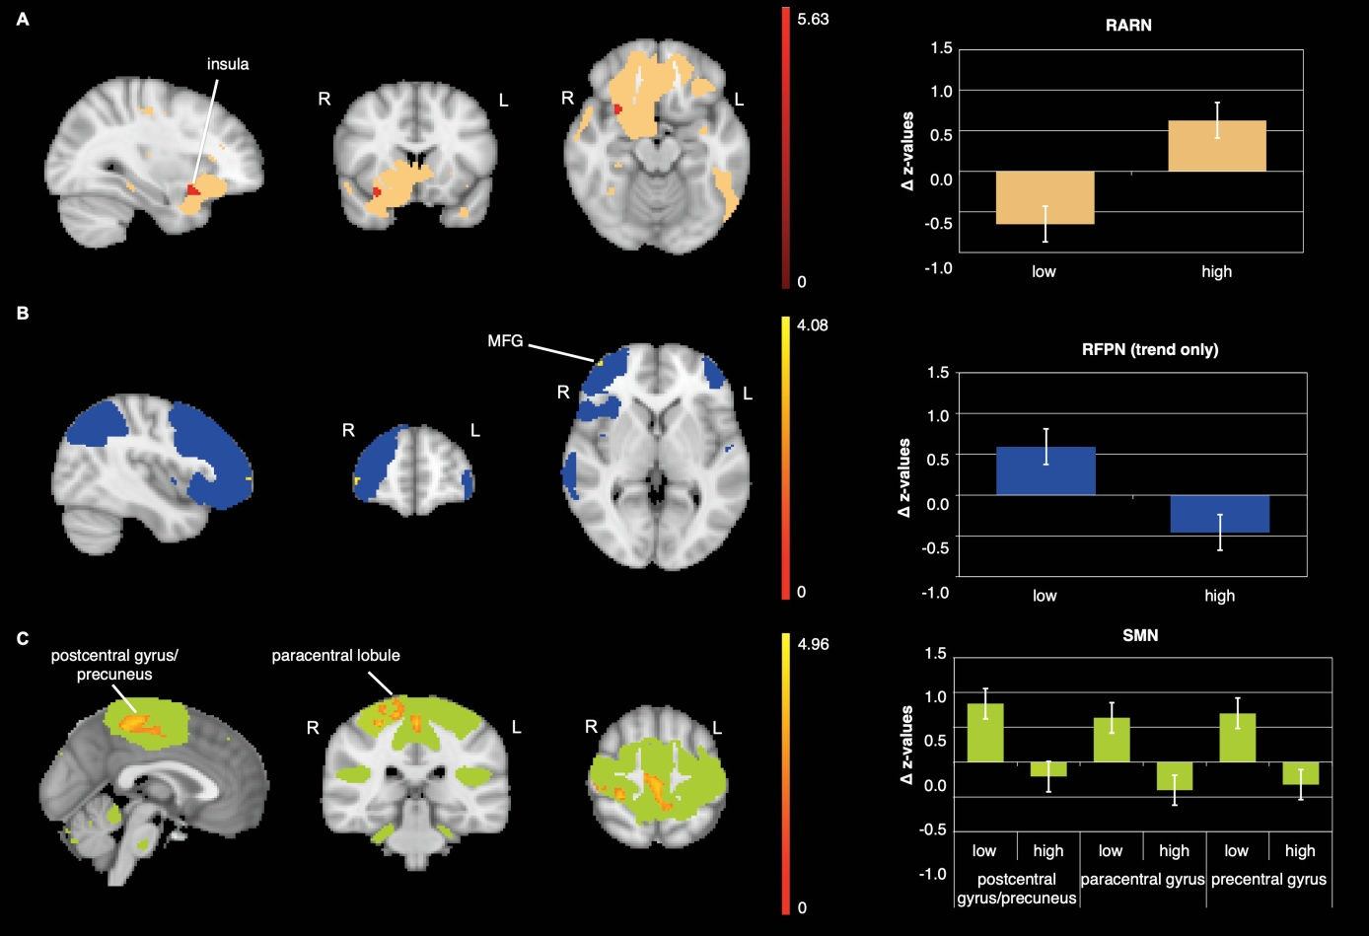
Figure S3: FC changes observed significantly different between conditions (‘low’ and ‘high’ intensity) after implementing nuisance regression (WM and CSF) in our analysis. Significant clusters in the interaction of the: A) RARN in the right anterior insula; B) RFPN in the right middle frontal gyrus (MFG; trend only p=0.086); C) SMN in the left postcentral gyrus/precuneus, paracentral gyrus and precentral gyrus; data shown is corrected for p<0.05, after multiple comparison correction using TFCE approach; z-values were normalized by dividing them by SD; The colors of clusters do not indicate increases or decreases; N=22; R = right; L = left.

brain region | side | k | x | y | z | p-value (tfce)
RARN - ‘high’ > ‘low’
insula | R | 33 | 30 | 14 | -18 | 0.013
RFPN - ‘low’ > ‘high’
middle frontal gyrus | R | 5* | 44 | 56 | 0 | 0.086**
SMN- ‘low’ > ‘high’
precuneus/postcentral gyrus | L | 758 | -2 | -40 | 56 | 0.015
paracentral gyrus | R | 35 | 8 | -44 | 76 | 0.044
precentral gyrus | L | 2* | -10 | -22 | 66 | 0.049
Table S3: Brain regions observed significantly different between conditions (‘low’ and ‘high’ intensity) in our analysis after implementing nuisance regression (WM and CSF). Coordinates presented are in MNI space; k = cluster size; N = 22; *small cluster size, needs to be treated with caution; ** represents a trend.

Default Mode Network
The DMN revealed no significant time x condition interaction in rs-FC. However, there was a significant increase in FC from pre to post ‘low’ exercise condition in the SFG (Figure S4-A, Table S4).

Left Affect and Reward Network
The LARN did not reveal a significant time x condition interaction in rs-FC. However, there was a significant increase in FC from pre to post ‘high’ exercise condition in the left OFC (Figure S4-B, Table S4).

Left Fronto Parietal Network
The LFPN did not reveal a significant time x condition interaction, but a significant increase in rs-FC from pre to post ‘low’ exercise condition in the inferior parietal lobule (IPL) (Figure S4-C, Table S4).

Other networks
We did not detect any further significant changes in FC in the other examined RSN. However, we could detect a statistical trend in the Salience network in the interaction time x condition (p=0.096).

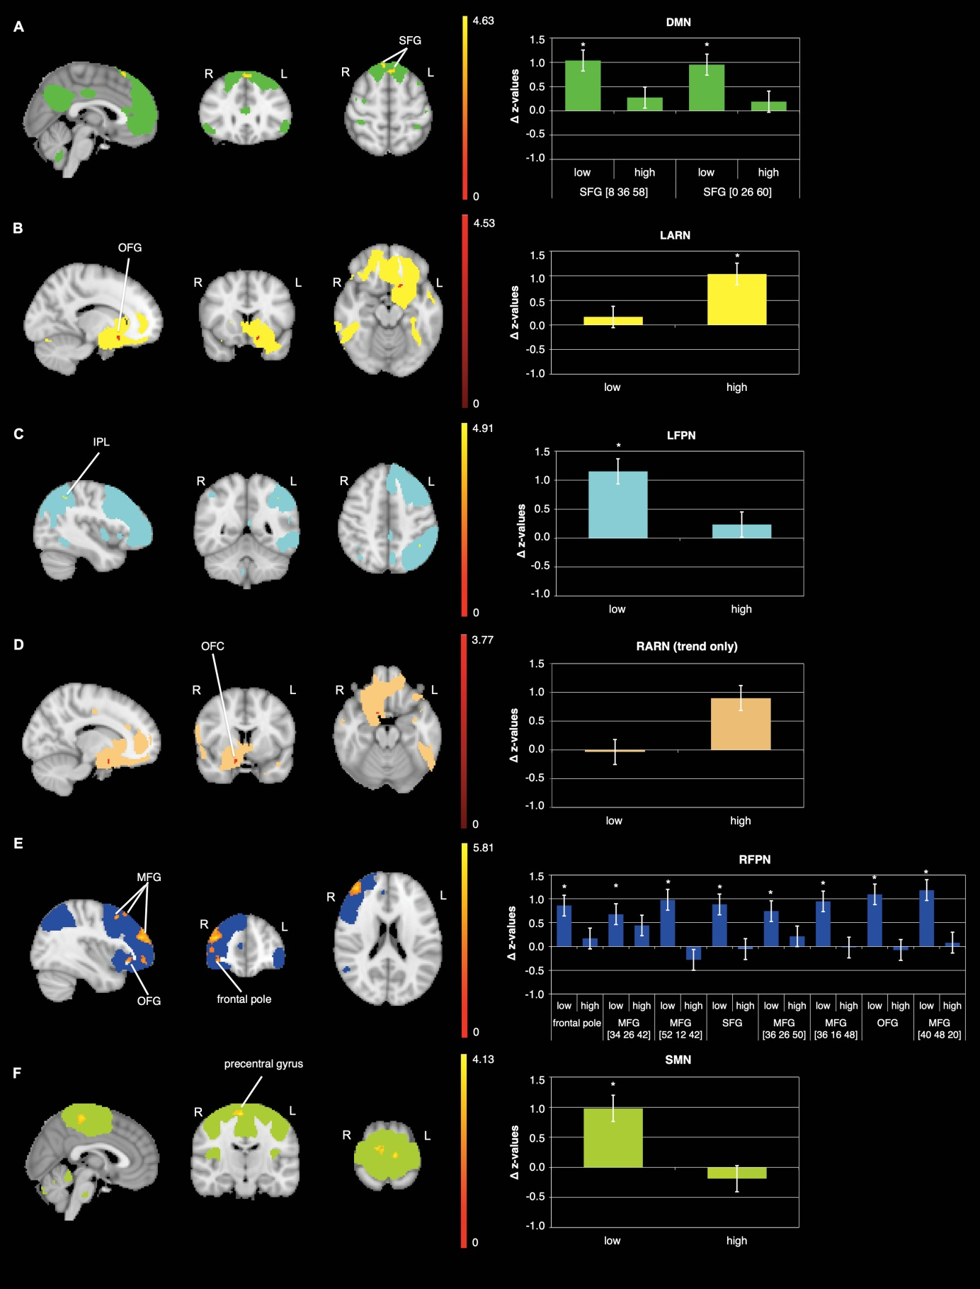
Figure S4: Differential effects in rs-FC from pre to post within each exercise condition in our analysis after implementing nuisance regession (WM and CSF). Rs-FC changes in the: A) DMN within the low condition (post>pre) in the superior frontal gyrus (SFG), B) LARN within the ‘high’ condition (pre>post) in the orbitofrontal cortex (OFC), C) LFPN within the ‘low’ condition (post>pre) in the inferior parietal lobule (IPL), D) RARN within the ‘high’ condition (post>pre) in the OFC, E) RFPN within the ‘low’ condition (post>pre) in the middle frontal gyrus (MFG), frontal pole, OFC ans SFG, F) SMN within the ‘low’ condition (post>pre) in the precentral gyrus; data shown is corrected for p<0.05, after multiple comparison correction using TFCE approach; z-values were normalized by dividing them by SD; The colors of clusters do not indicate increases or decreases; N=22; R = right; L = left; *indicates significant change in FC.

brain region | side | k | x | y | z | p-value (tfce)
DMN – ‘low’ post>pre
superior frontal gyrus |  | 39 | 0 | 26 | 60 | 0.027
superior frontal gyrus | R | 15 | 8 | 36 | 58 | 0.031
LARN – ‘high’ post>pre
orbitofrontal cortex | L | 9* | -14 | 16 | -16 | 0.031
RARN – ‘high’ post>pre
orbitofrontal cortex | R | 5* | 14 | 6 | -20 | 0.084**
LFPN – ‘low’ post>pre
inferior parietal lobule | L | 3* | -40 | -50 | 46 | 0.042
RFPN – ‘low’ post>pre
middle frontal gyrus | R | 496 | 40 | 48 | 20 | 0.004
orbitofrontal cortex | R | 98 | 38 | 30 | -8 | 0.032
middle frontal gyrus | R | 22 | 36 | 16 | 48 | 0.018
middle frontal gyrus | R | 16 | 36 | 26 | 50 | 0.046
superior frontal gyrus | L | 12 | -2 | 28 | 50 | 0.045
middle frontal gyrus | R | 8* | 52 | 12 | 42 | 0.046
middle frontal gyrus | R | 4* | 34 | 26 | 42 | 0.048
frontal pole | R | 2* | 32 | 36 | 22 | 0.048
SMN – ‘low’ post>pre
precentral gyrus | R | 162 | 6 | -28 | 62 | 0.032
Table S4: Brain regions observed significantly different between pre and post within each exercise condition in our analysis after implementing nuisance regression (WM and CSF). Coordinates presented are in MNI space; k = cluster size; N = 22; *small cluster size, needs to be treated with caution; ** represents a trend.

Subgroup analysis after implementing nuisance regression (WM and CSF) and including HR as covariate of no interest
Analogue to the analysis without nuisance regression we needed to exclude some of our subjects when additionally including HR as covariate of no interest. Due to artifacts in recording HR (heart rate) during the resting state functional magnetic resonance imaging (rs-fMRI) scan, we needed to exclude N=4 subjects for investigating the interaction effects between time (pre and post) and condition (‘low’ and ‘high’), and N=2 subjects for each exercise intervention resulting in a sample size of N=20 to compare pre to post ‘low’ exercise intensity and pre to post ‘high’ exercise intensity.

Right Affect and Reward Network
In the RARN we found no significant time x condition interaction in rs-FC anymore. However, we could detect a trend in the insula, ACC/paracingulate cortex and OFC from pre to post ‘high’ exercise intensity (Figure S6-C, Table S6).

Right Fronto Parietal Network
Results of the rs-FC analysis in the RFPN indicated a significant time x condition interaction in the right MFG (Figure S5-A, Table S5), driven by a significant increase in FC after ‘low’ exercise intensity in the right MFG, SFG and the left cerebellar crus 1, but also an increase after the ‘high’-intensity condition in the inferior parietal lobule (IPL) (Figure S6-D, Table S6).

Sensorimotor Network
The rs-FC analysis in the SMN revealed a significant time x condition interaction in the postcentral gyrus, precentral gyrus and precuneus (Figure S5-B, Table S5). Comparing pre versus post ‘high’ exercise condition showed a significant decrease in rs-FC in the ppstcentral gyrus (Figure S6-F, Table S6).

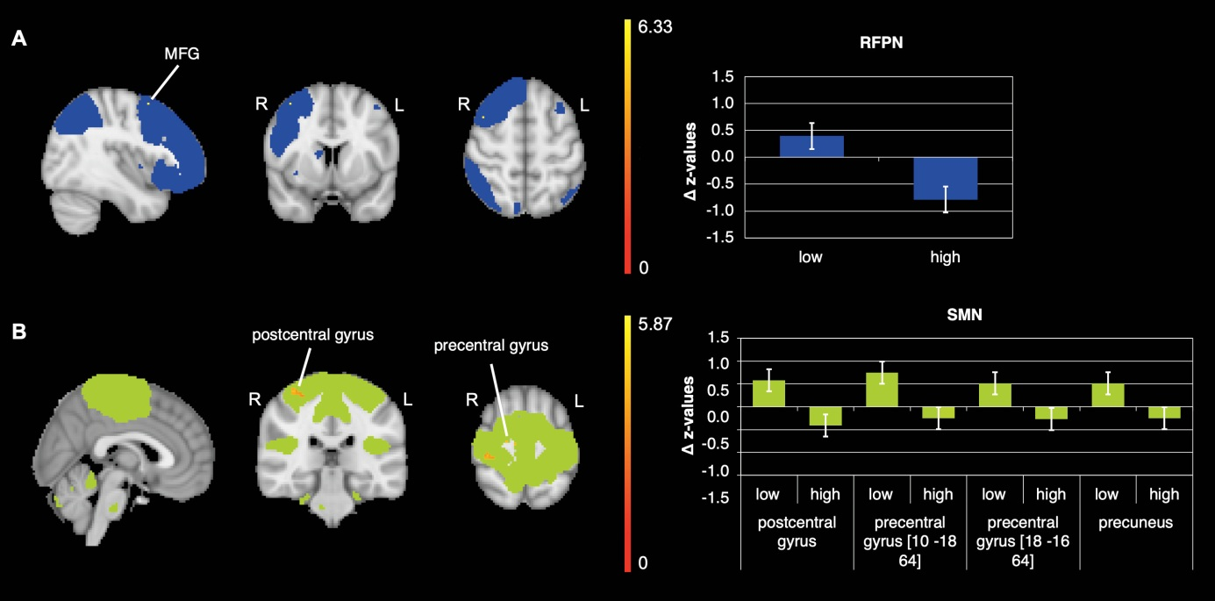
Figure S5: FC changes observed significantly different between conditions (‘low’ and ‘high’ intensity) when including HR as covariate of no interest in our analyses after implementing nuisance regression (WM and CSF). Significant clusters in the interaction of the: A) RFPN in the right middle frontal gyrus (MFG); B) SMN in the right postcentral gyrus, precentral gyrus and precuneus; data shown is corrected for p<0.05, after multiple comparison correction using TFCE approach; z-values were standardized by dividing them by the SD; The colors of clusters do not indicate increases or decreases; N=18; R = right; L = left.

brain region | side | k | x | y | z | p-value (tfce)
RFPN - ‘low’ > ‘high’
middle frontal gyrus | R | 1* | 40 | 8 | 56 | 0.038
SMN - ‘low’ > ‘high’
postcentral gyrus | R | 49 | 36 | -30 | 64 | 0.036
precentral gyrus | R | 7* | 10 | -18 | 64 | 0.030
precentral gyrus | R | 5* | 18 | -16 | 64 | 0.038
precuneus |  | 1* | 0 | -40 | 56 | 0.048
Table S5: Brain regions observed significantly different between conditions (‘low’ and ‘high’ intensity) when including HR as covariate of no interest in our analyses after implementing nuisance regression (WM and CSF). Coordinates presented are in MNI space; k = cluster size; N = 18; *small cluster size, needs to be treated with caution.

Default mode network
The DMN revealed no significant time x condition interaction in rs-FC. However, there was a significant increase in FC from pre to post ‘low’ exercise condition in the left SFG (Figure S6-A, Table S6).

Left Affect and Reward Network
The LARN did not reveal a significant time x condition interaction in rs-FC. However, there was a significant increase in FC from pre to post ‘high’ exercise condition in the ACC/paracingulate cortex, OFC and medial frontal cortex (Figure S6-B, Table S6).

Other networks
We did not detect any further interactions, however, we detected a significant decrease from pre to post ‘high’ exercise intensity in the middle temporal gyrus in the salience network (Figure S6-E, Table S6).

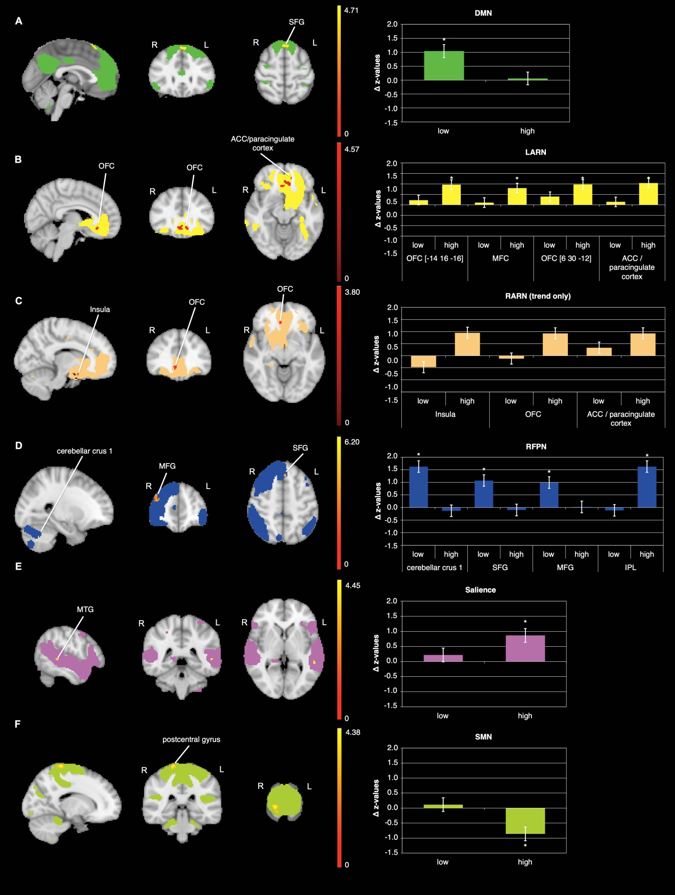
Figure S6: Differential effects in rs-FC from pre to post exercise when including HR as covariate of no interest in our analysis after implementing nuisance regression (WM and CSF). Rs-FC changes in the: A) DMN within the ‘low’ condition (post>pre) in the superior frontal gyrus (SFG), B) LARN within the ‘high’ condition (post>pre) in the orbitofrontal cortex (OFC), paracingulate cortex/anterior cingulate cortex (ACC) and medial frontal cortex (MFC), C) RARN within the ‘high’ condition in the insula, ACC/paracingulate cortex and OFC, D) RFPN within the ‘low’ condition (post>pre) in the MFG , SFG, and cerebellar crus 1, as well as in the ‘high’ condition (post>pre) in the inferior parietal lobule (IPL), E) Salience within the ‘high’ condition (post>pre) in the middle temporal gyrus (MTG), F) SMN within the ‘high’ condition (pre>post) in postcentral gyrus; data shown is corrected for p<0.05, after multiple comparison correction using TFCE approach; z-values were standardized by dividing them by the SD; The colors of clusters do not indicate increases or decreases; N=20; R = right; L = left.
brain region | side | k | x | y | z | p-value (tfce)
DMN – ‘low’ post>pre
superior frontal gyrus | L | 47 | -2 | 28 | 58 | 0.021
LARN – ‘high’ post>pre
paracingulate gyrus / ACC | L | 45 | -8 | 32 | -10 | 0.015
orbitofrontal cortex | R | 21 | 6 | 30 | -12 | 0.024
medial frontal cortex | L | 3* | -12 | 42 | -12 | 0.049
orbitofrontal cortex | L | 1* | -14 | 16 | -16 | 0.049
RARN – ‘high’ post>pre
paracingulate gyrus / ACC | R | 12 | 6 | 34 | -10 | 0.083**
orbitofrontal cortex | R | 5* | 14 | 6 | -20 | 0.088**
insula | R | 1* | 28 | 14 | -16 | 0.089**
RFPN – ‘low’ post>pre
middle frontal gyrus | R | 61 | 40 | 50 | 28 | 0.034
superior frontal gyrus | L | 9* | -2 | 24 | 52 | 0.041
cerebellar crus 1 | L | 4* | -24 | -62 | -38 | 0.037
RFPN – ‘high’ post>pre
inferior parietal lobule | L | 2* | -50 | -44 | 42 | 0.039
Salience – ‘high’ post>pre
middle temporal gyrus | L | 6* | -52 | -40 | 2 | 0.043
SMN – high pre>post
postcentral gyrus | R | 68 | 18 | -34 | 74 | 0.053**
Table S6: Brain regions observed significantly different between pre and post within each exercise condition when including HR as covariate of no interest in our analyses after implementing nuisance regression (WM and CSF). Coordinates presented are in MNI space; k = cluster size; N = 20; *small cluster size, needs to be treated with caution; **represents a trend.

