Xpert in hematuria patients suppl material R2 1/9/2024
Supplemental material:

Supplemental figures:

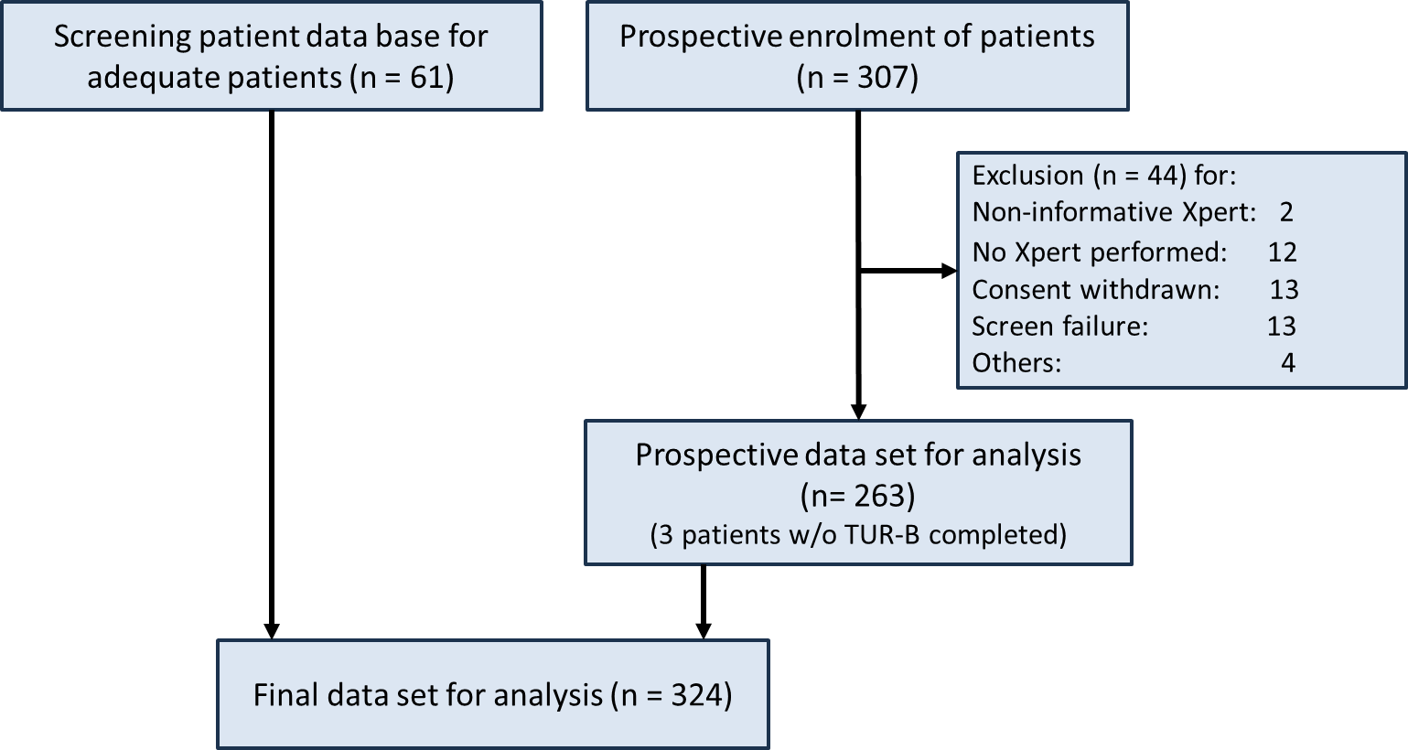

Supplemental figure 1: Flow chart patient recruitment

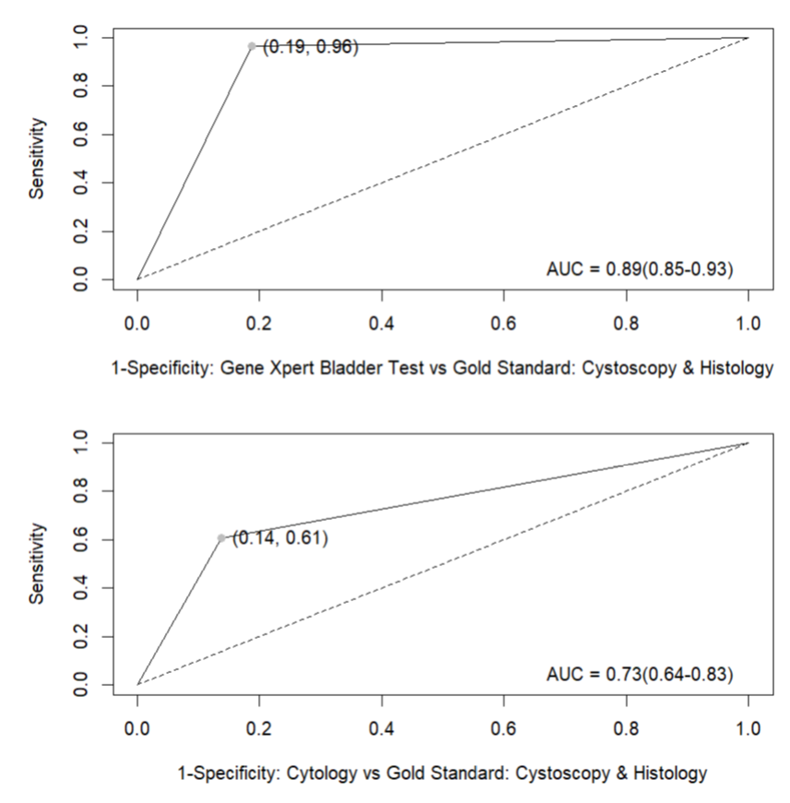

Supplemental figure 2: ROC Analysis with AUC for urine cytology and Xpert BC-D in hematuria patients vs. reference standard (pathology)
Supplemental tables:

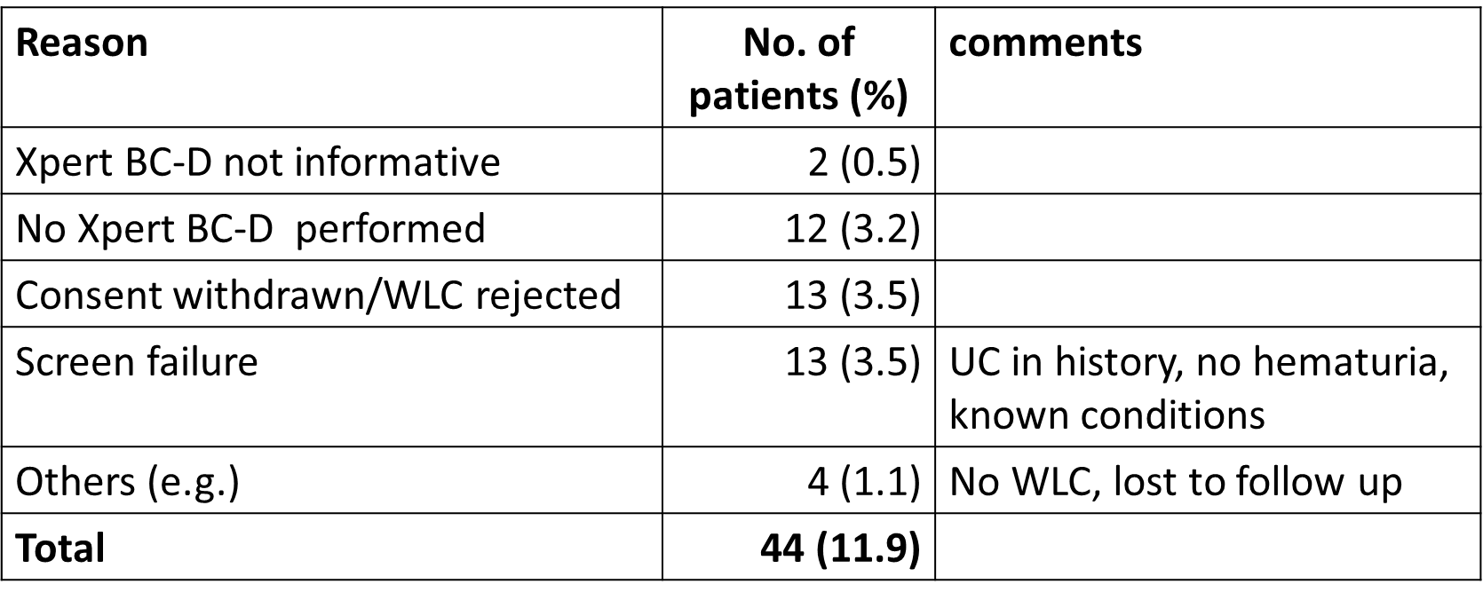

Supplemental table 1: Reasons for excluding patients from study.

Parameter | Prospective (n=263) | Retrospective (n=61) | p-value  (Fisher Exact)
Age  (19, 30)  (30, 50)  (50, 65)  (65, 75)  (75, 90) | 10 (3.8%)  44 (16.7%)  120 (45,6%)  55 (20.9%)  34 (12.9%) | 0 (0%)  6 (9.8%)  24 (39.3%)  20 (32.8%)  11 (18%) | 0.0911
Sex  Female  Male | 117 (44.5%)  146 (55.5%) | 19 (31.1%)  42 (68.9% | 0.0622
Hematuria  Microhematuria  Gross hematuria | 170 (64.6%)  93 (35.4%) | 43 (70.5%)  18 (29.5%) | 0.455
Xpert BC-D result  Negative  Positive | 198 (75.3%)  65 (24.7%) | 42 (68.9%)  19 (31.1%) | 0.458
Urine cytology  none  Negative  Positive | 20 (7.6%)  204 (77.6%)  39 (14.9) | 4 (6.6%)  41 (67.2%)  16 (26.2%) | 0.147
 | Included in Analysis  (n=262) | Included in Analysis  (n=59)
Urothelial cancer*  Negative  Positive  None (excluded) | 239 (90.9%)  23 (8.7%)  1 (0.4%) | 54 (88.5%)  5 (8.2%)  2 (3.3%) | 1
 | UC Positive  (n=23) | UC Positive  (n=5)
Tumor grade  Low grade  High grade | 7 (2.7%)  16 (6.1%) | 1 (1.6%)  4 (6.6%) | 1

Supplemental table 2: Patient characteristics in prospective (n=263) and retrospective (n=61) patient cohort. 3 excluded per protocol as TURBT was recommended but not completed

Parameter | NUE (n = 324)* | IMC (n = 828)**
Age median (years) | 61 | 65
Male (%) | 58 | 56
Microhematuria (%) | 66 | 46
Urothelial tumors (%) | 8.6 | 7.1
Sensitivity Xpert BC-D (%) | 96 | 78
Sensitivity cytology (%) | 61 | 44
Specificity Xpert BC-D (%) | 80 | 84
Specificity cytology (%) | 86 | 97
* This study, ** Valenberg FJPV et al. Eur Urol Oncol 2021 [11]

Supplemental table 3: Comparison of key data from this study and the international multicenter trial.

 | Total | Xpert BC-D neg/ WLC pos | Xpert BC-D neg/  WLC neg | Xpert BC-D pos. + WLC pos- | Xpert BC-D pos./ WLC neg. | Extended follow-up
 | 321 | 5 | 234 | 37 | 45
US only | 235 | 4 | 180 | 29 | 22 (%)
US + advanced imaging (CT, MRI) | 86 (27%) | 1 (20%) | 54 (30%) | 8 (22%) | 23 (51%) | + 3 (=58%)
RR: 1.64,
95% CI [1.14, 2.36]
p = 0.013

Supplemental table 4: Correlation between Xpert BC-D result and referral for advanced imaging

Further supplemental material (not for publication)

Sample size calculations:

- The sample size to detect sensitivity between GX and cytology for all grade tumors
  - The aim of study :
A recent multicenter studies has demonstrated that the Xpert bladder cancer detect has a higher sensitivity than urinary cytology in the detection of UC including low-grade tumors .

  - Hypothesis :
H0: The sensitivity of GX > the sensitivity of Cytology among HG & LG patients
Ha: The sensitivity of GX <= the sensitivity of Cytology among HG & LG patients

  - The parameters used in sample size calculation :

The estimated true sensitivity of GX: 91.7%
The estimated true sensitivity of Cytology:58.3%
Alpha:5%
The prevalence :8.2%
Software :PASS15

  - Sample size result
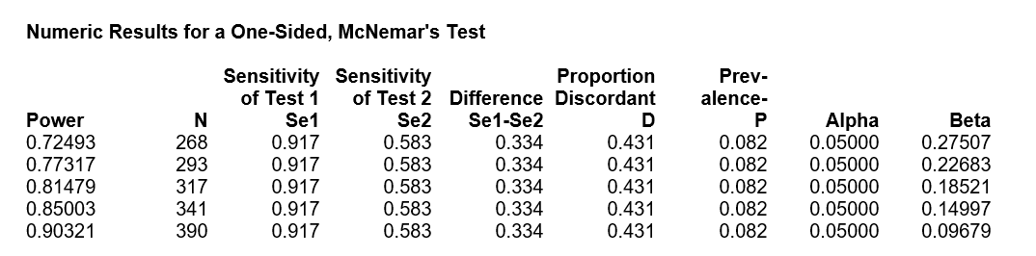

  - Conclusion :
A sample size of 341 subjects achieves 85% power to detect a difference of 0.334 between two diagnostic tests whose sensitivities are 0.917 and 0.583. This procedure uses a one-sided McNemar test with a significance level of 0.05000. The prevalence of disease in the population is 0.082. The proportion of discordant pairs is 0.431.

with 350 subjects, we should have more than 85% power to detected difference between GX and cytology for all grade tumors.

- The sample size to detect sensitivity between GX and cytology for Low grade tumor
  - Aim of study :
A recent multicenter studies has demonstrated that the Xpert bladder cancer detect has a higher sensitivity than urinary cytology in the detection of UC including low-grade tumors .

  - Hypothesis :
H0: The sensitivity of GX > the sensitivity of Cytology among LG patients
Ha: The sensitivity of GX <= the sensitivity of Cytology among LG patients

  - The parameters used in sample size calculation :

The estimated true sensitivity of GX: 66.7%
The estimated true sensitivity of Cytology:10%
Alpha:5%
The prevalence :2.1%
Software :PASS15

  - Sample size result
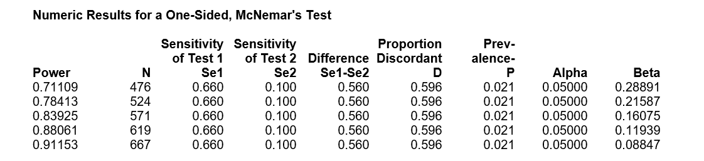

  - Conclusion :
A sample size of 476 subjects achieves 71% power to detect a difference of 0.560 between two
diagnostic tests whose sensitivities are 0.660 and 0.100. This procedure uses a one-sided
McNemar test with a significance level of 0.05000. The prevalence of disease in the population
is 0.021. The proportion of discordant pairs is 0.596.

with 350 subjects, we only have 34.8% power to detected difference between GX and cytology for low grade tumors.

