Supplementary table 1. pathologic findings of all rats, urinary bladder tissue
Groups | rats |  | Hypertrophic vascular wall | Urothelial atrophy | hyperplasia | hyperemia
control | Female | 1 | - | - | - | -
 |  | 2 | - | - | - | -
 |  | 3 | - | - | - | -
 |  | 4 | - | - | - | +
 |  | 5 | - | - | - | -
 |  | 6 | - | - | - | +
 | male | 1 | - | - | - | -
 |  | 2 | - | - | - | -
 |  | 3 | - | - | - | -
 |  | 4 | - | - | - | -
 |  | 5 | - | - | - | -
 |  | 6 | - | - | - | -
Opium | Female | 1 | - | + | - | +
 |  | 2 | + | - | - | -
 |  | 3 | - | - | - | -
 |  | 4 | - | - | - | -
 |  | 5 | - | + | - | -
 |  | 6 | - | - | + | -
 | male | 1 | - | ++++ | - | -
 |  | 2 | - | +++ | - | -
 |  | 3 | - | ++++ | - | -
 |  | 4 | - | +++ | - | -
 |  | 5 | - | ++++ | - | -
 |  | 6 | - | ++++ | - | +
morphine | Female | 1 | +++ | - | +++ | +++
 |  | 2 | +++ | - | ++ | ++
 |  | 3 | ++ | - | ++ | +++
 |  | 4 | +++ | - | ++ | ++
 |  | 5 | +++ | - | +++ | ++
 |  | 6 | ++ | - | +++ | +++
 | male | 1 | - | +++ | - | -
 |  | 2 | - | ++ | + | +
 |  | 3 | + | +++ | - | -
 |  | 4 | - | ++ | + | -
 |  | 5 | - | +++ | - | -
 |  | 6 | - | ++ | - | +
-: negative, +: mild, ++: moderate, +++ & ++++: severe

Supplementary figure 1. Histopathological sections of the urinary bladder. Female rats. Control group. H&E staining; ×100, ×200, ×400
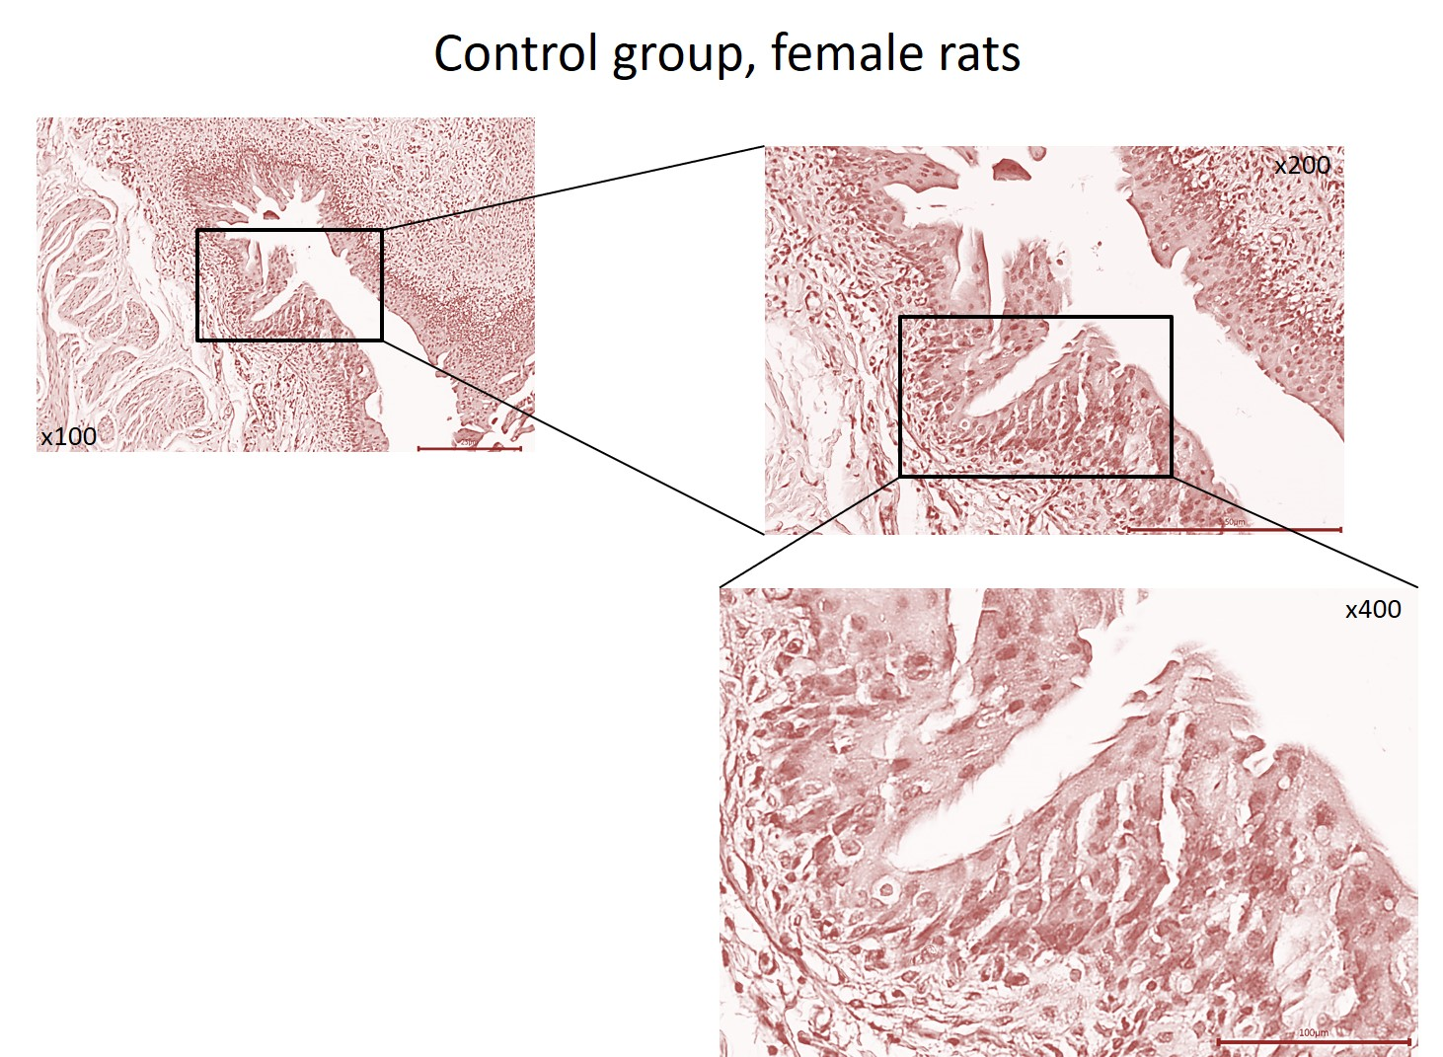

Supplementary figure 2. Histopathological sections of the urinary bladder. male rats. Control group. H&E staining; ×100, ×200, ×400
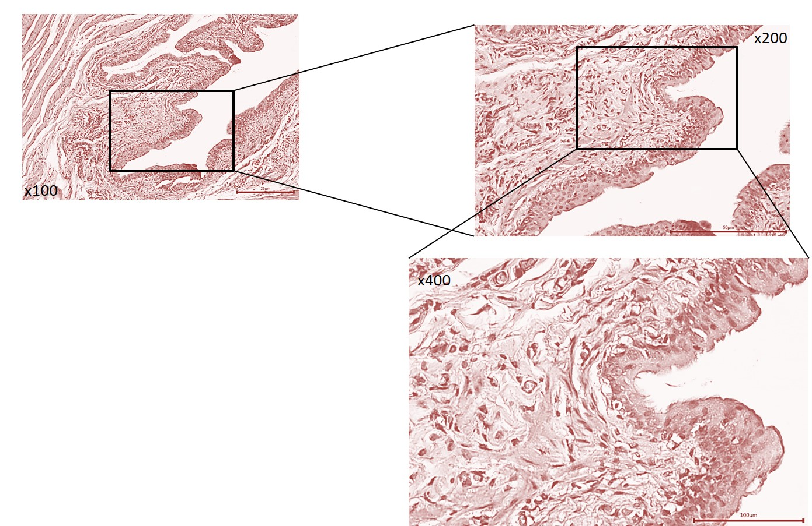

Supplementary figure 3. Histopathological sections of the urinary bladder. Female rats. opium group. H&E staining; ×100, ×200, ×400

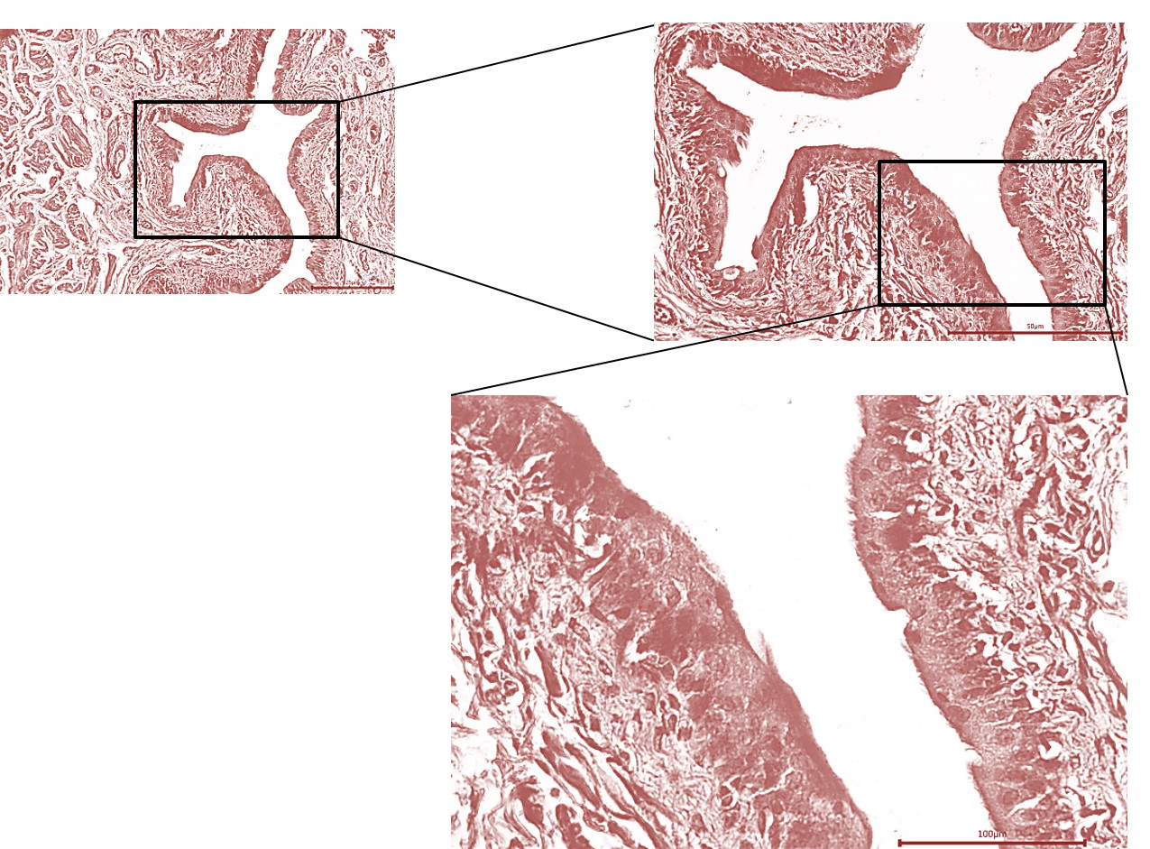

Supplementary figure 4. Histopathological sections of the urinary bladder. Male rats. opium group. H&E staining; ×100, ×200, ×400

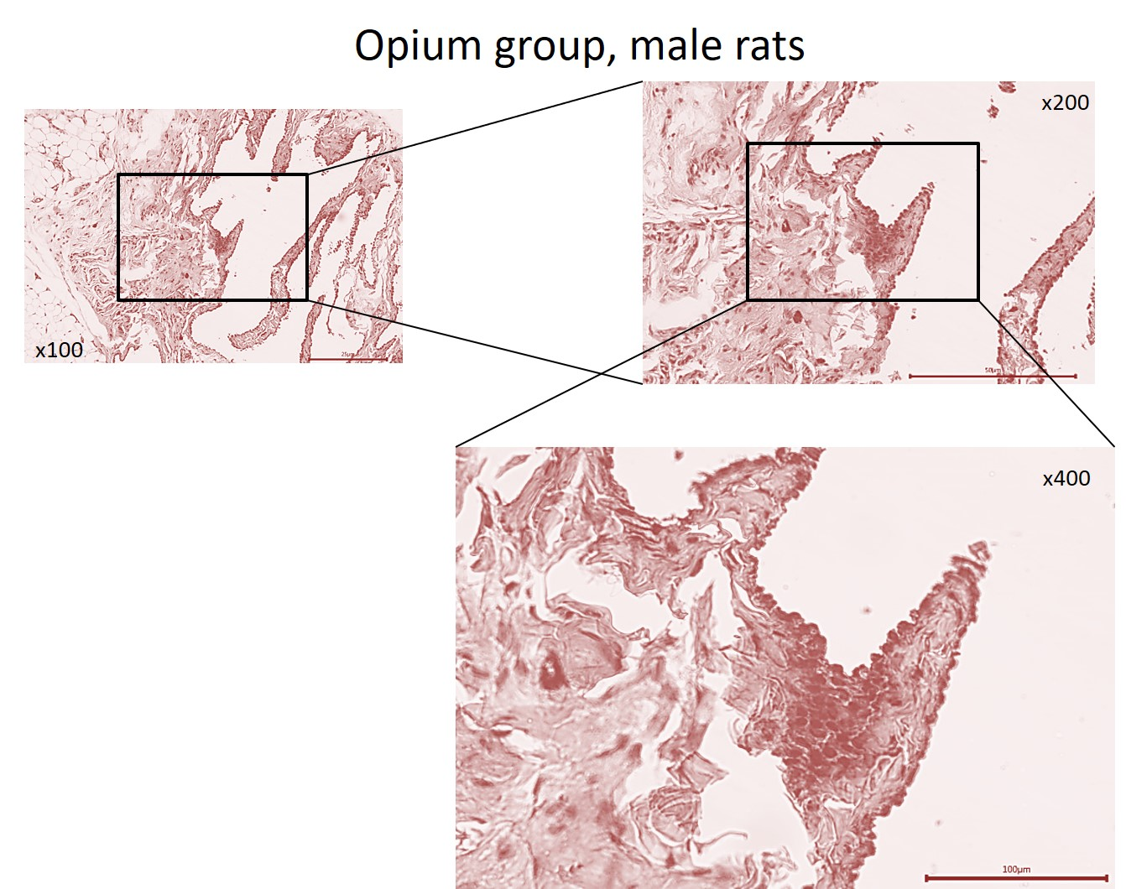

Supplementary figure 5. Histopathological sections of the urinary bladder. female rats. morphine group. H&E staining; ×100, ×200, ×400
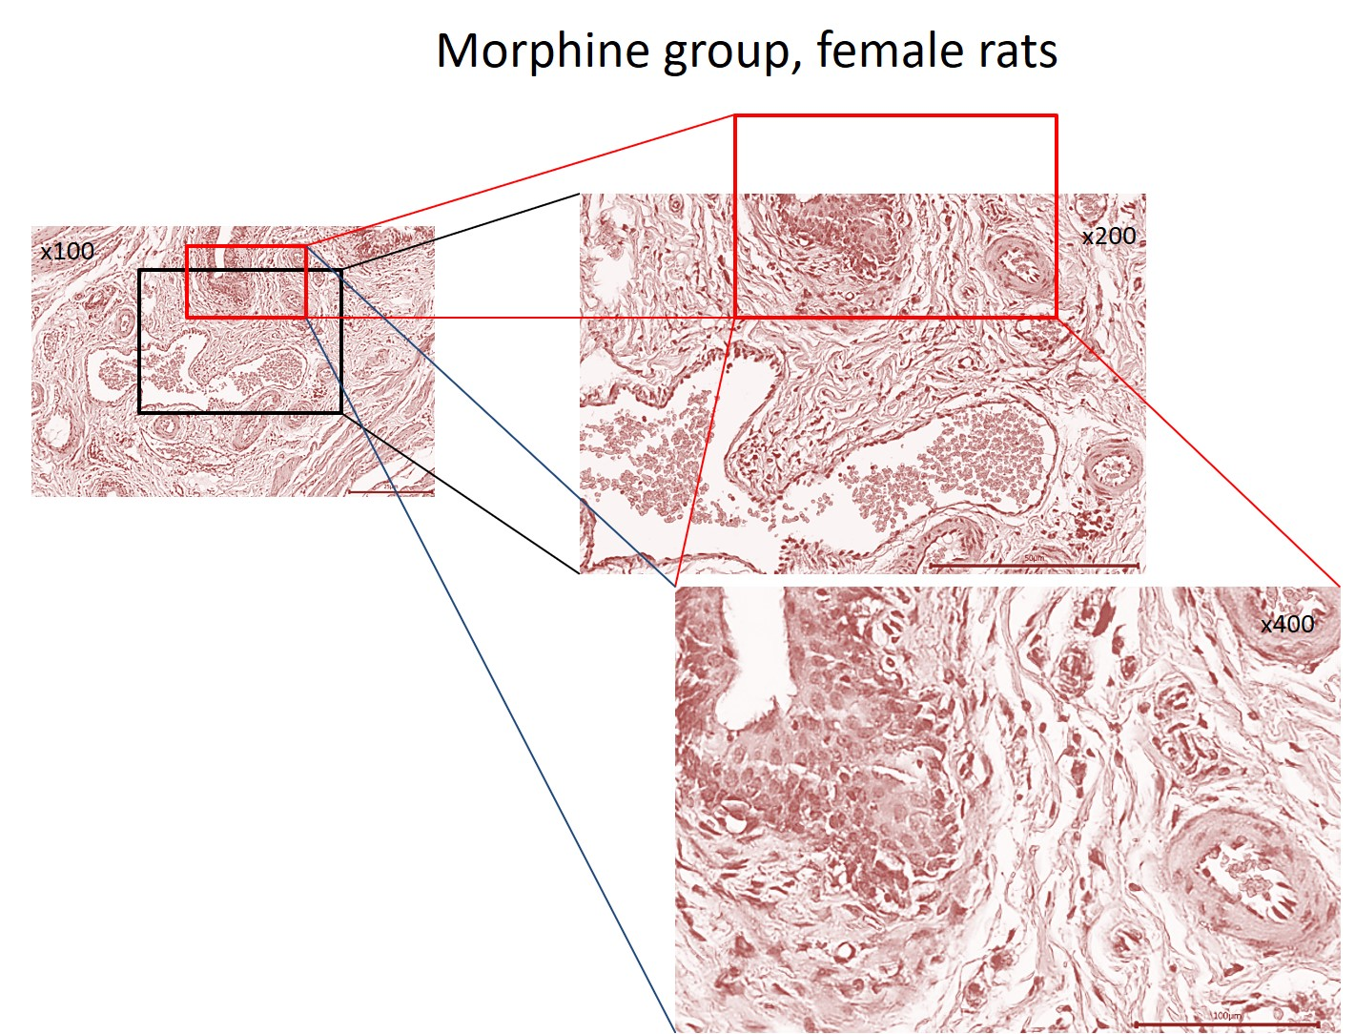

Supplementary figure 6. Histopathological sections of the urinary bladder. male rats. morphine group. H&E staining; ×100, ×200, ×400