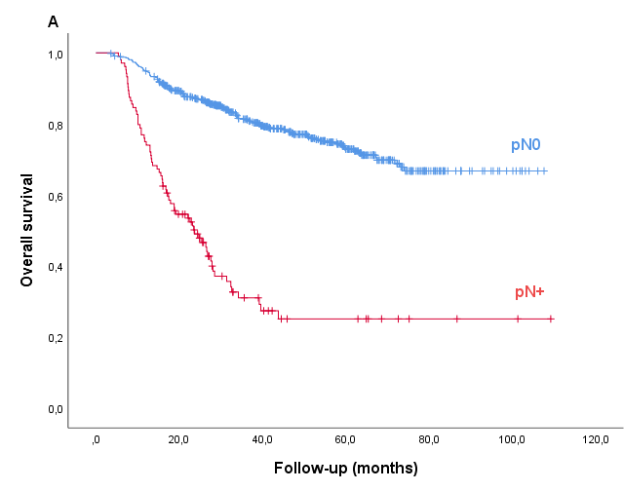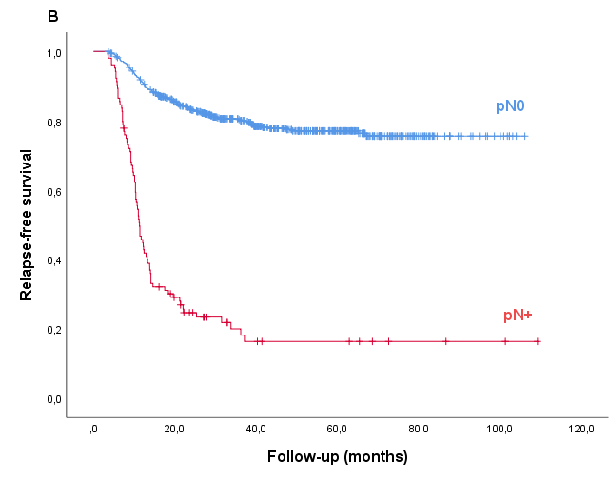

Supplementary Fig. 1. Overall survival (A), and relapse-free survival (B) for patients with pN0 versus pN+ and any T-stage.

