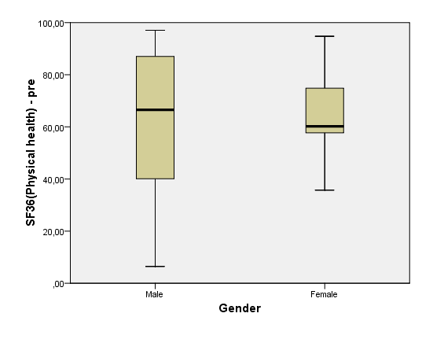
Effect of Gender on pre-treatment SF-36 Physical scores

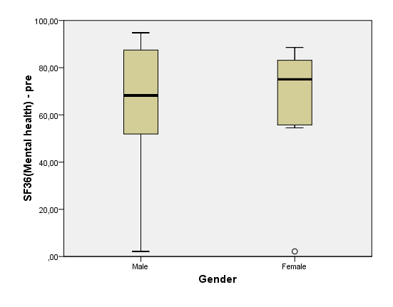
Effect of Gender on pre-treatment SF-36 Mental scores

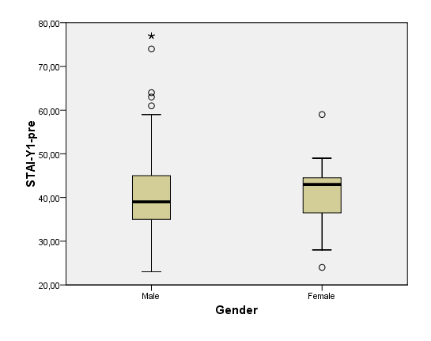
Effect of Gender on pre-treatment STAI-Y1 scores

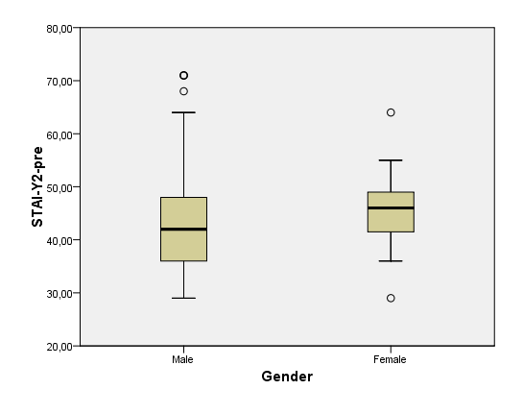

Effect of Gender on pre-treatment STAI-Y2 scores

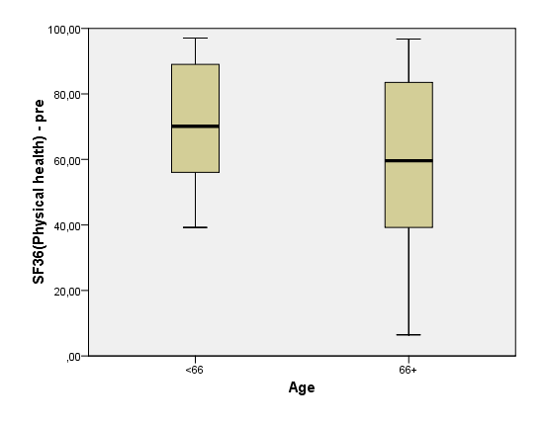
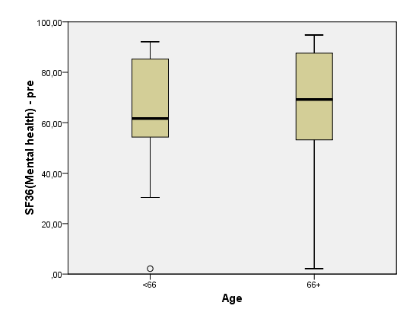
Effect of Age on pre-treatment SF-36 Physical scores

Effect of Age on pre-treatment SF-36 Mental scores

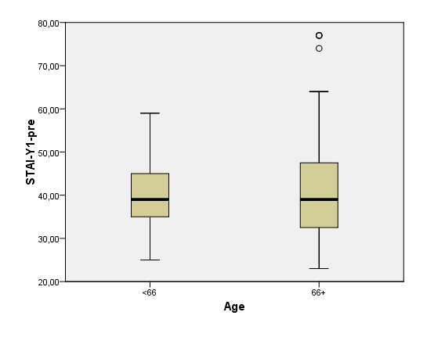
Effect of Age on pre-treatment STAI-Y1 scores

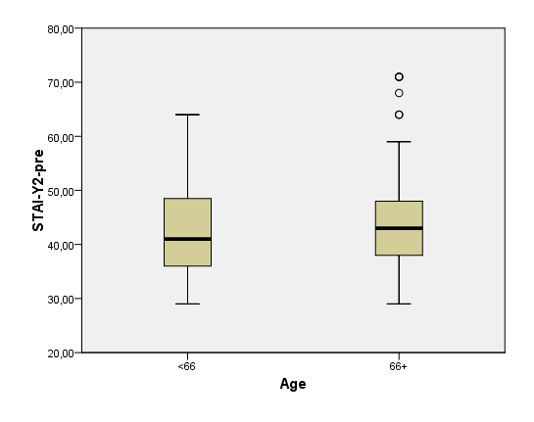
Effect of Age on pre-treatment STAI-Y2 scores

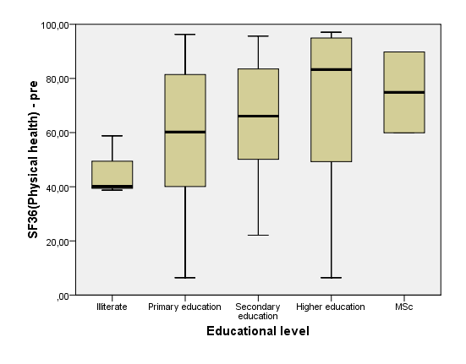
Effect of Educational level on pre-treatment SF-36 Physical scores

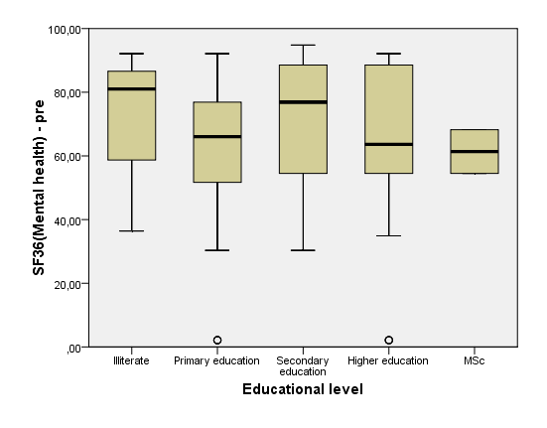
Effect of Educational level on pre-treatment SF-36 Mental scores

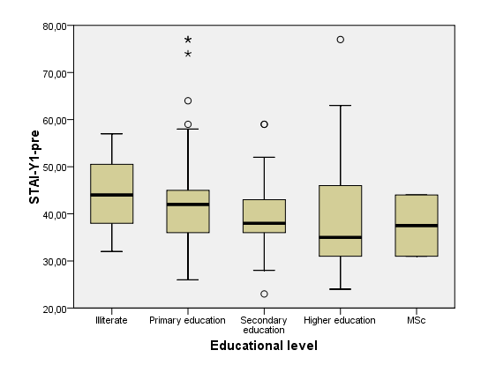
Effect of Educational level on pre-treatment STAI-Y1 scores

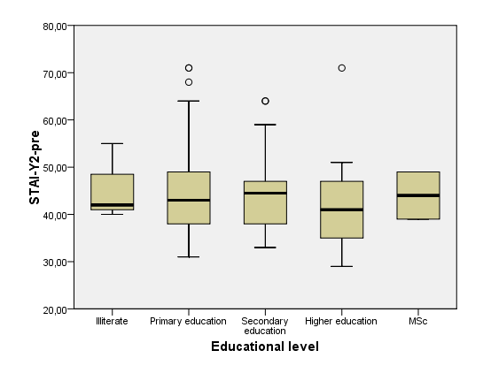
Effect of Educational level on pre-treatment STAI-Y2 scores

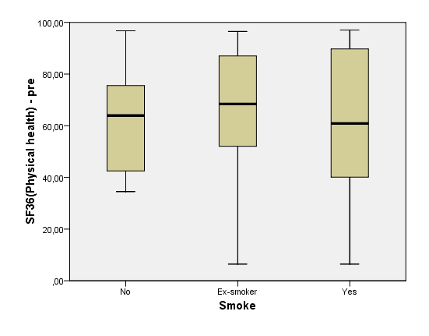
Effect of Smoking on pre-treatment SF-36 Physical scores

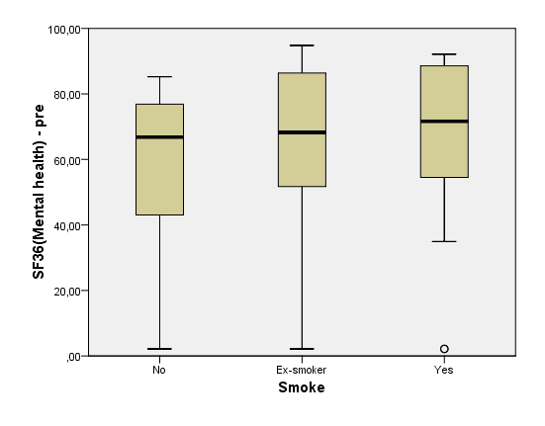
Effect of Smoking on pre-treatment SF-36 Mental scores

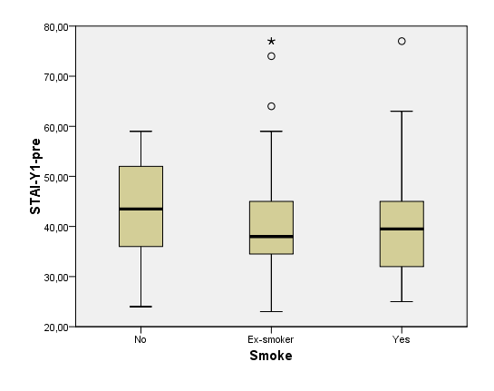
Effect of Smoking on pre-treatment STAI-Y1 scores
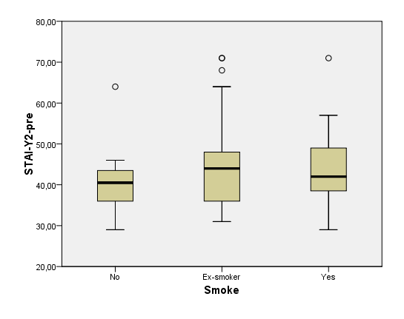
Effect of Smoking on pre-treatment STAI-Y2 scores

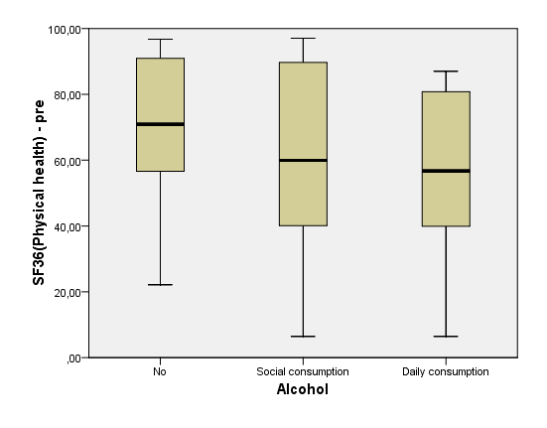

Effect of Alcohol on pre-treatment SF-36 Physical scores

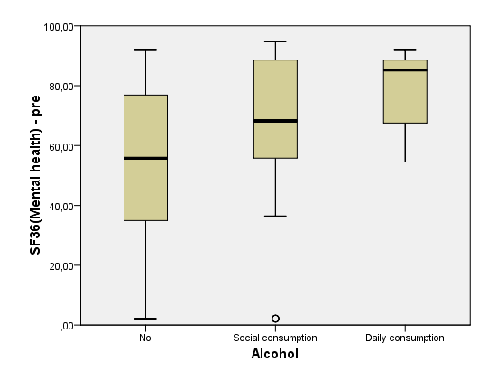

Effect of Alcohol on pre-treatment SF-36 Mental scores

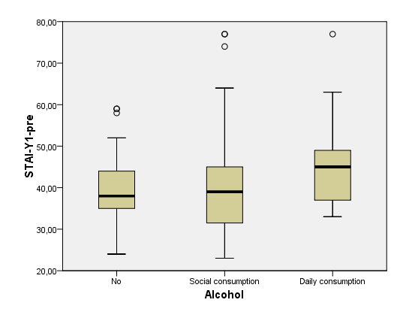

Effect of Alcohol on pre-treatment STAI-Y1 scores

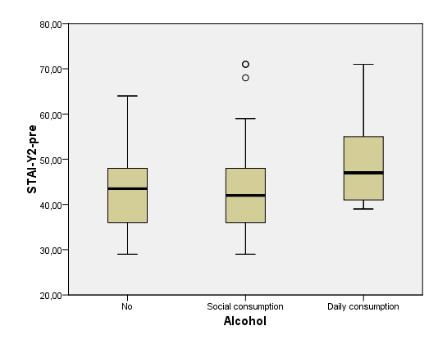

Effect of Alcohol on pre-treatment STAI-Y2 scores

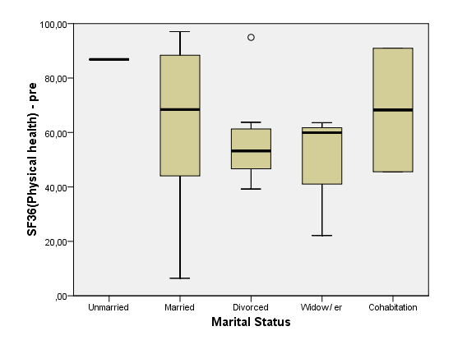

Effect of Marital Status on pre-treatment SF-36 Physical scores

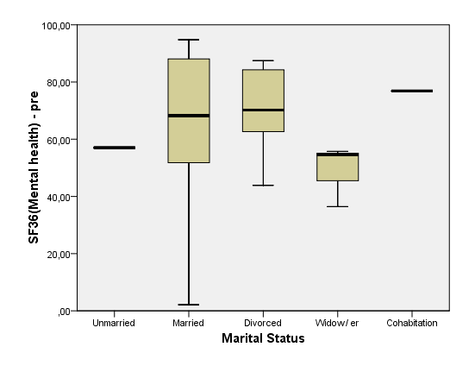

Effect of Marital Status on pre-treatment SF-36 Mental scores

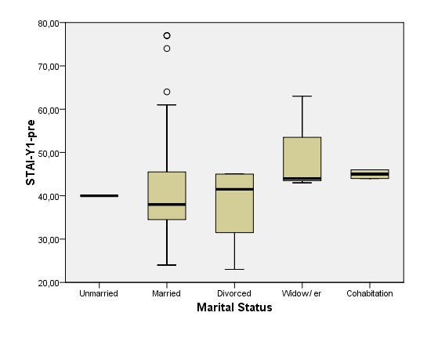
Effect of Marital Status on pre-treatment STAI-Y1 scores

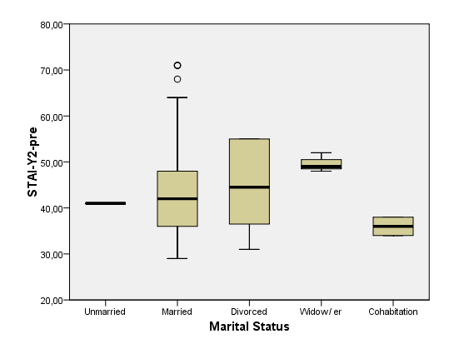

Effect of Marital Status on pre-treatment STAI-Y2 scores

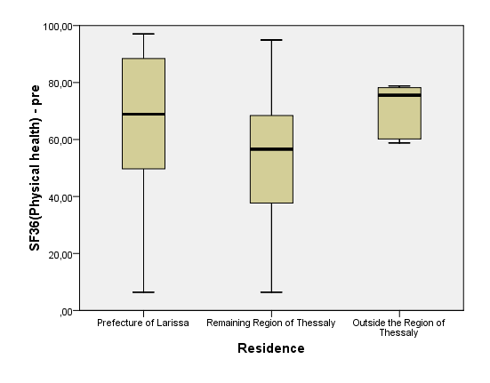

Effect of Residence on pre-treatment SF-36 Physical scores

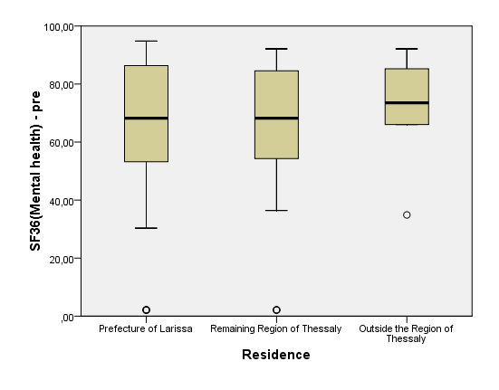

Effect of Residence on pre-treatment SF-36 Mental scores

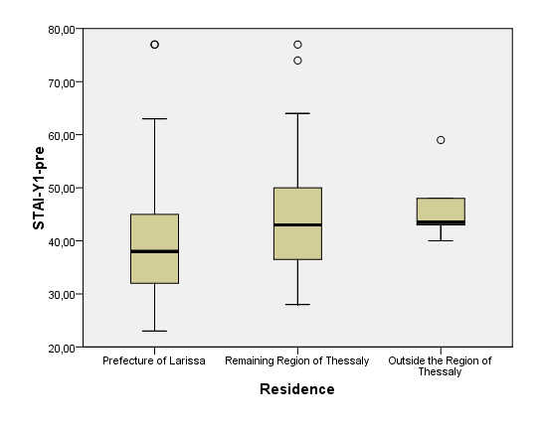

Effect of Residence on pre-treatment STAI-Y1 scores

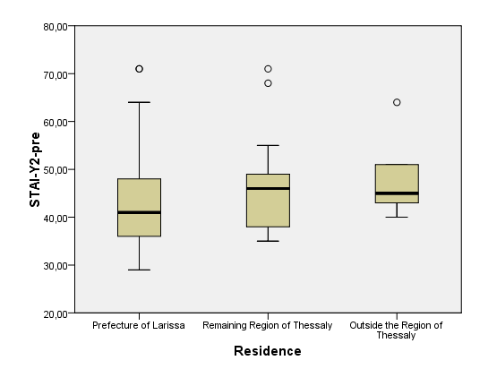

Effect of Residence on pre-treatment STAI-Y2 scores

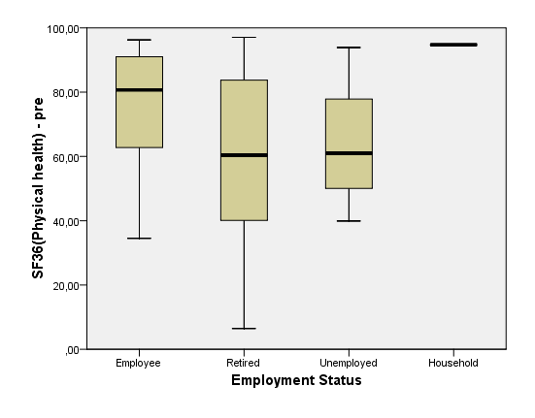

Effect of Employment Status on pre-treatment SF-36 Physical scores

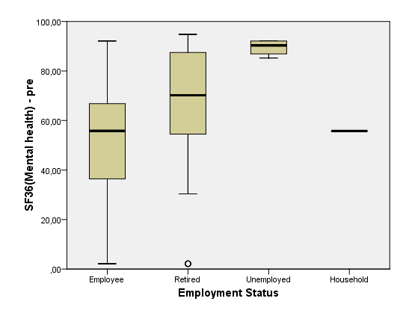

Effect of Employment Status on pre-treatment SF-36 Mental scores

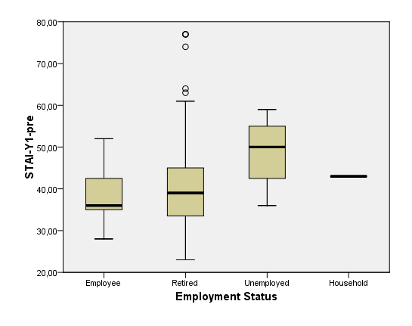

Effect of Employment Status on pre-treatment STAI-Y1 scores

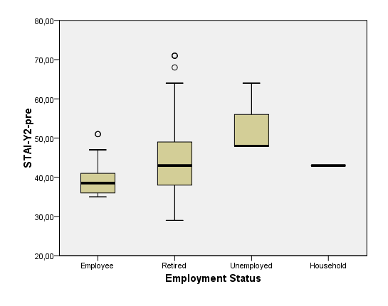

Effect of Employment Status on pre-treatment STAI-Y2 scores

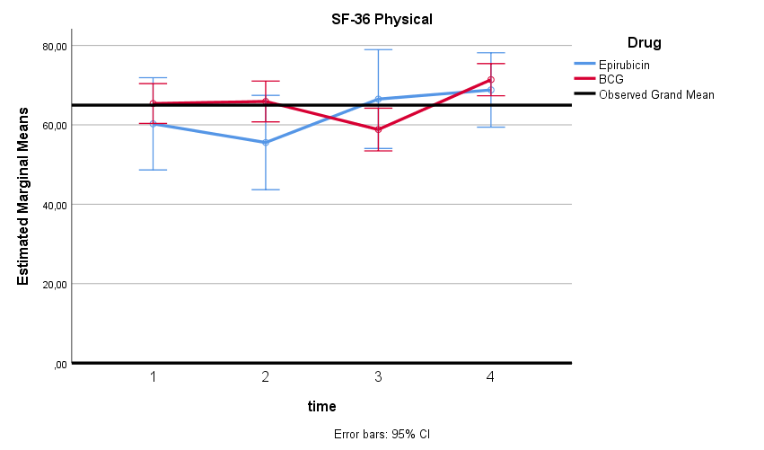
SF-36 Physical Scores of Treatment modalities

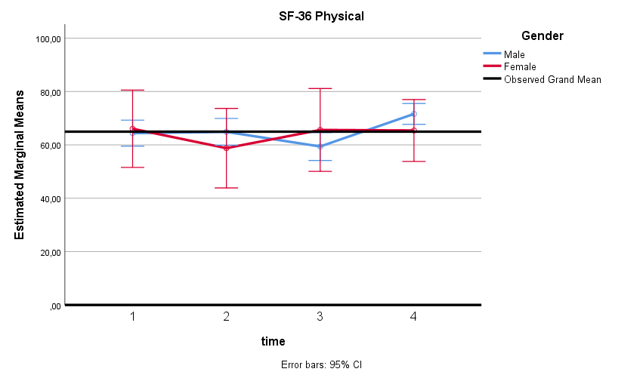
SF-36 Physical Scores of Gender

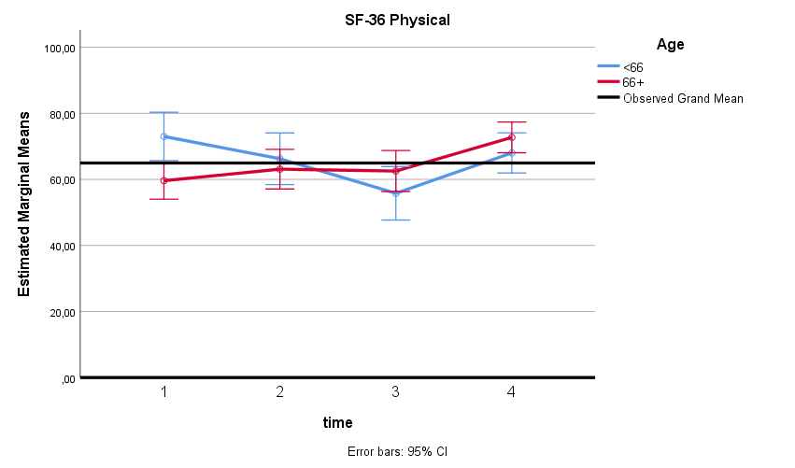
SF-36 Physical Scores of Age

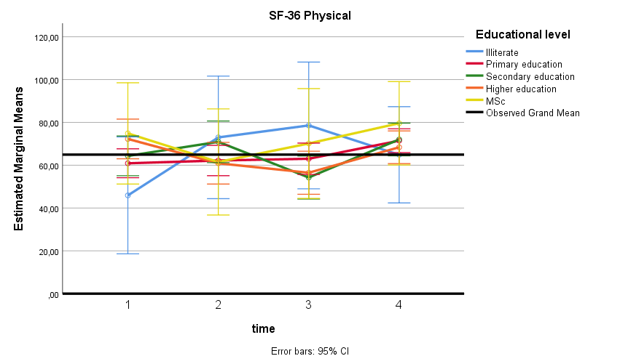
SF-36 Physical Scores of Educational level

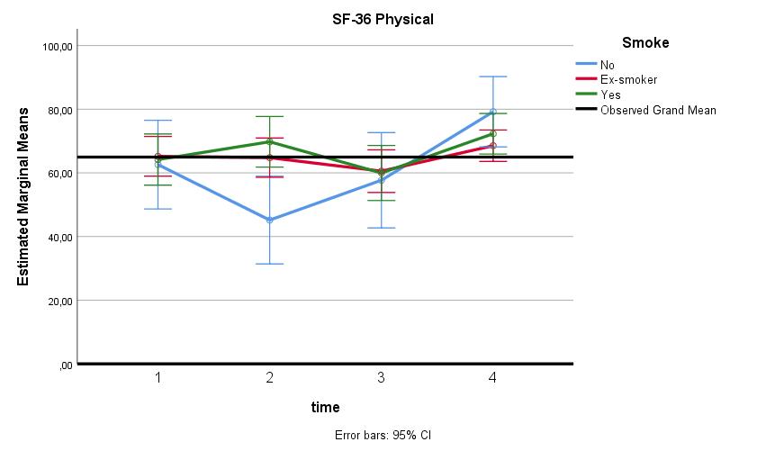
SF-36 Physical Scores of Smoking

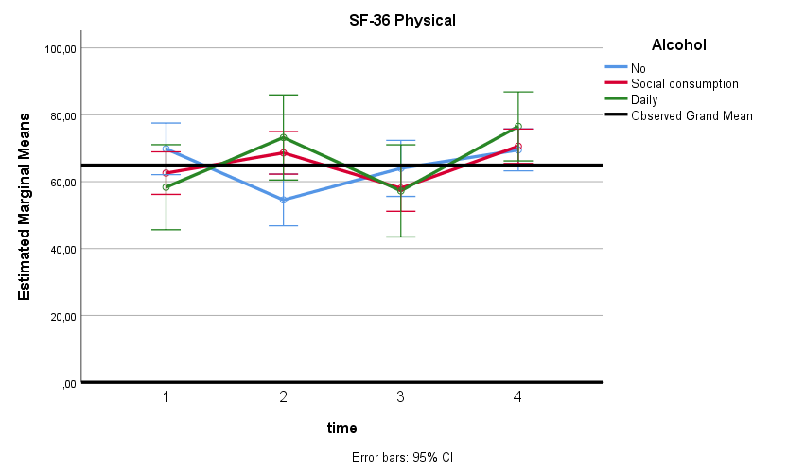
SF-36 Physical Scores of Alcohol

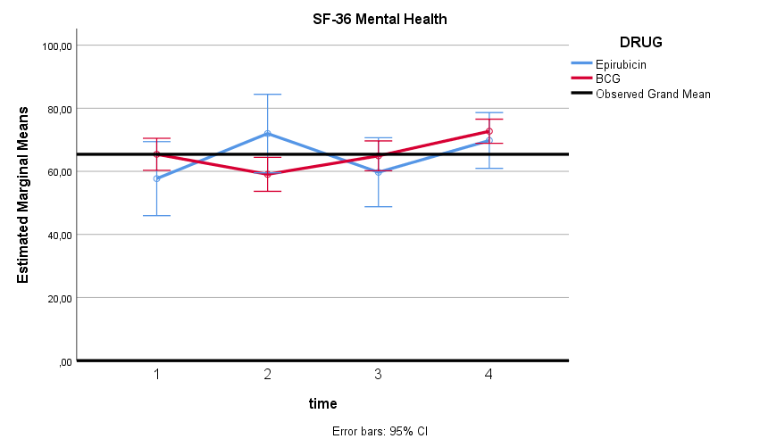
SF-36 Mental Scores of Treatment modalities

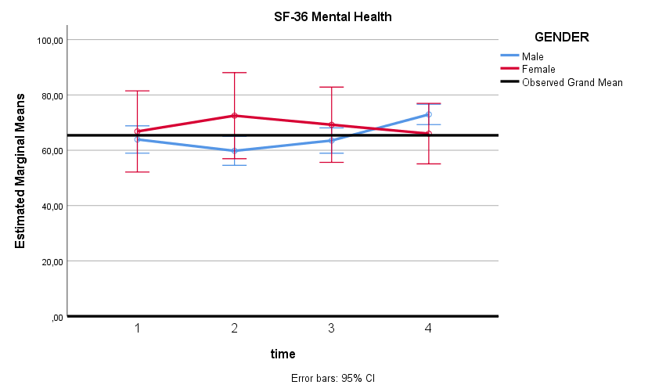
SF-36 Mental Scores of Gender

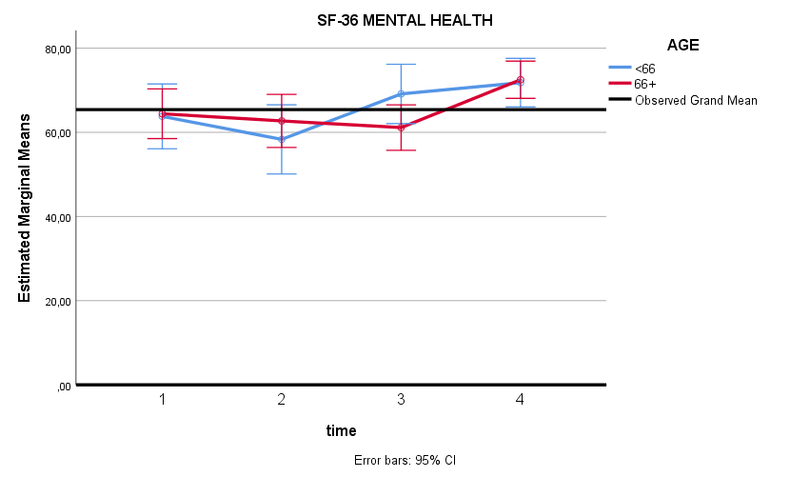

SF-36 Mental Scores of Age

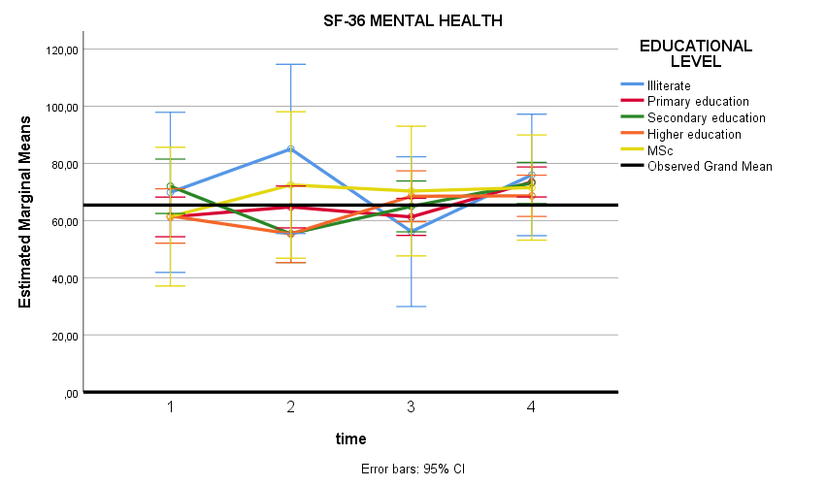
SF-36 Mental Scores of Educational level

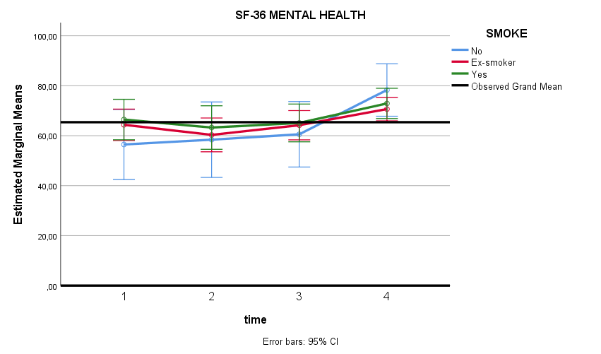
SF-36 Mental Scores of Smoking

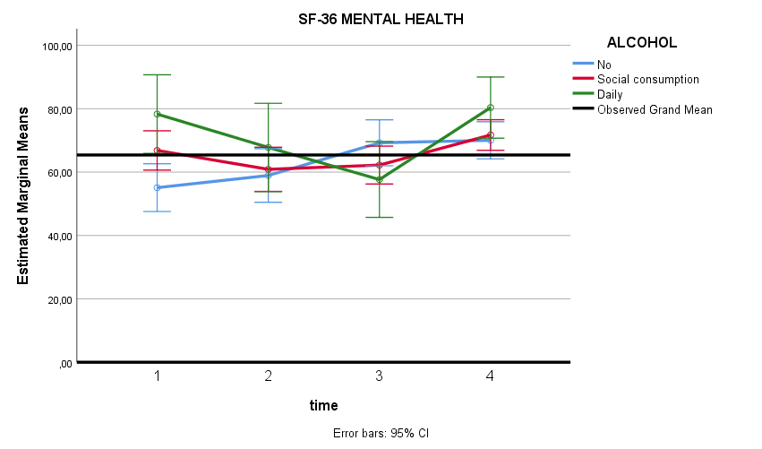
SF-36 Mental Scores of Alcohol

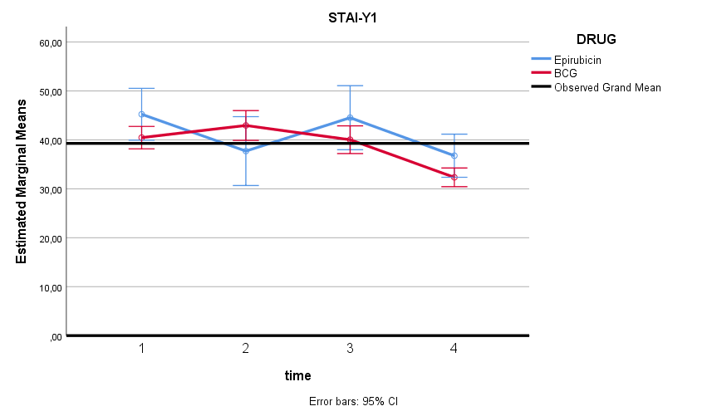

STAI-Y1 Scores of Treatment modalities

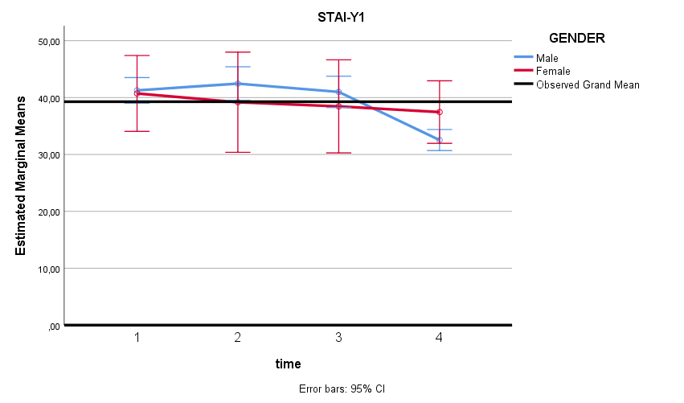
STAI-Y1 Scores of Gender

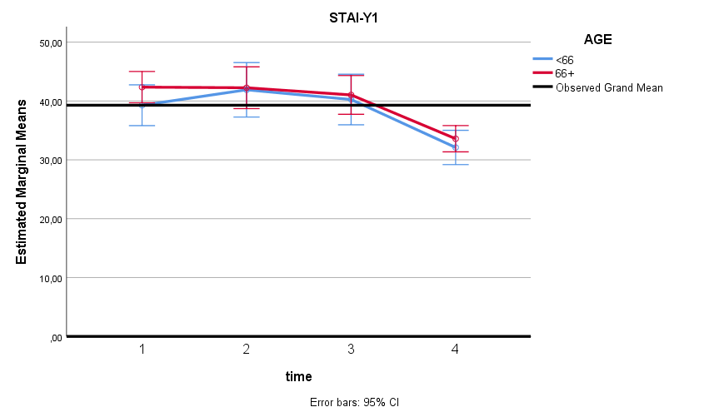
STAI-Y1 Scores of Age

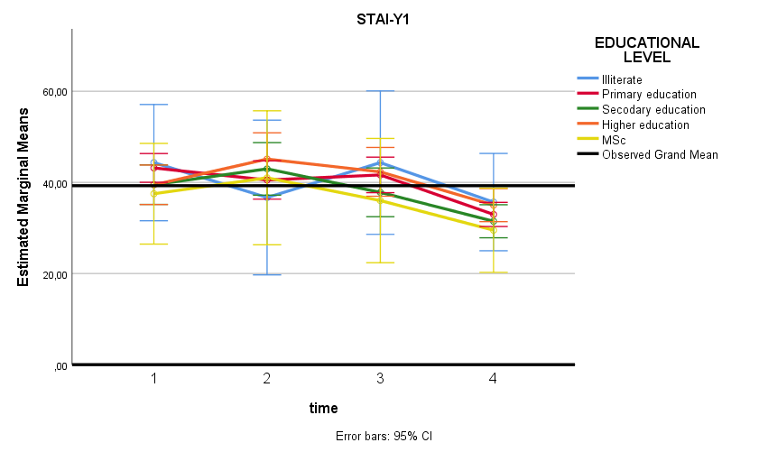
STAI-Y1 Scores of Educational Level

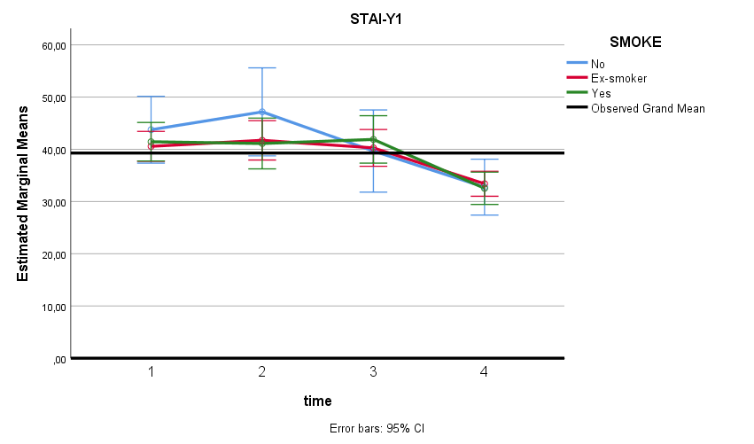

STAI-Y1 Scores of Smoking

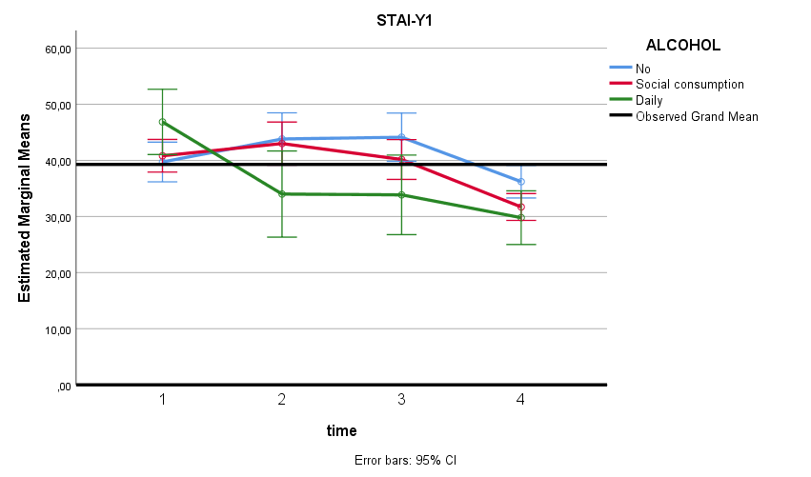
STAI-Y1 Scores of Alcohol

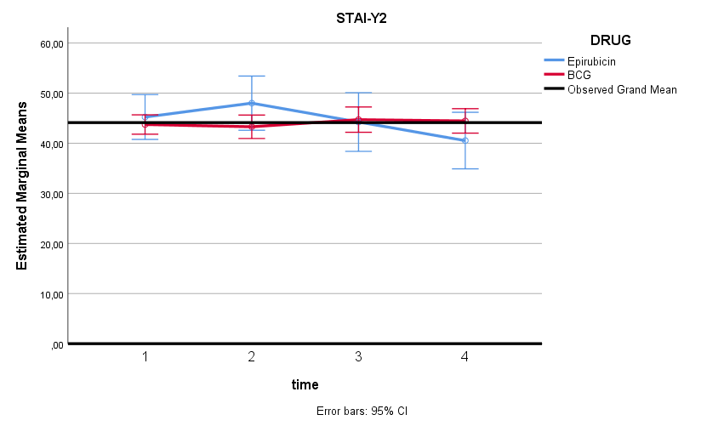
STAI-Y2 Scores of Treatment modalities

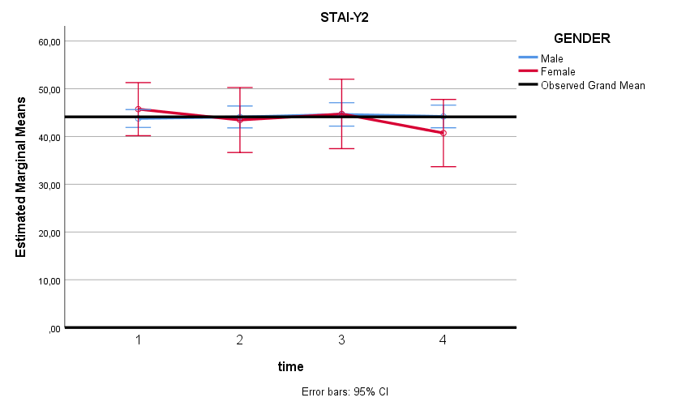

STAI-Y2 Scores of Gender

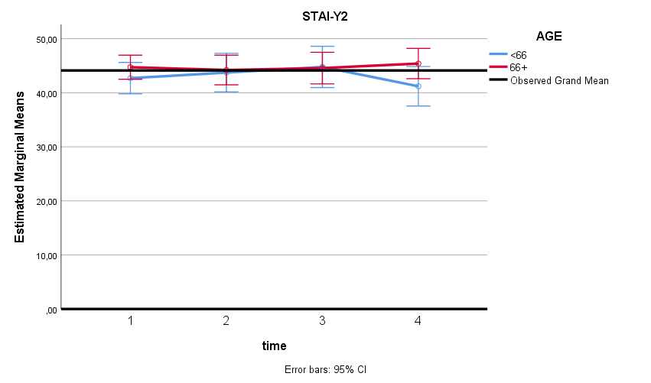
STAI-Y2 Scores of Age

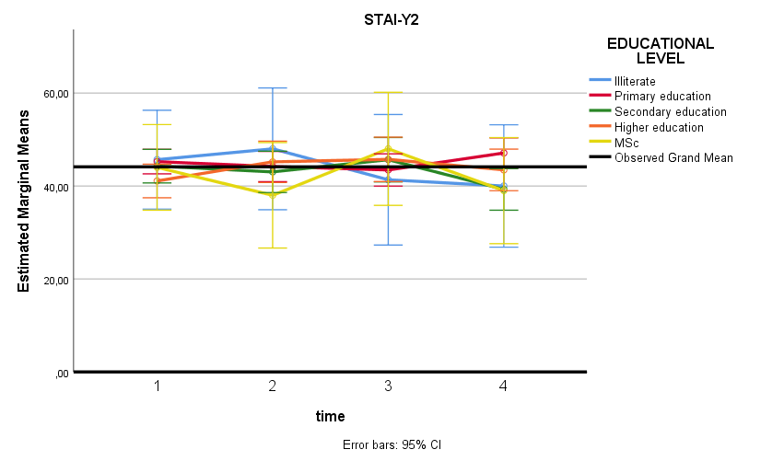
STAI-Y2 Scores of Educational Level

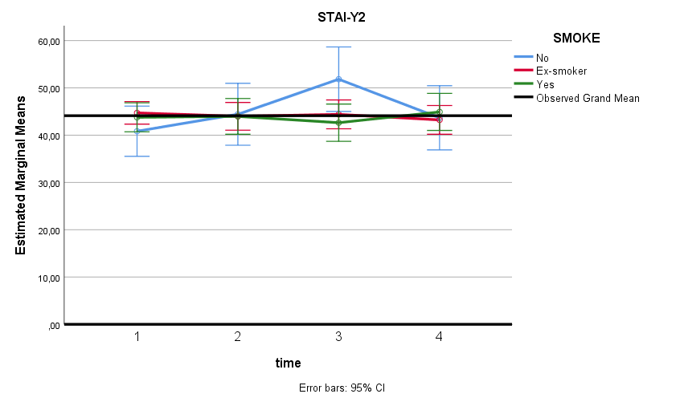

STAI-Y2 Scores of Smoking

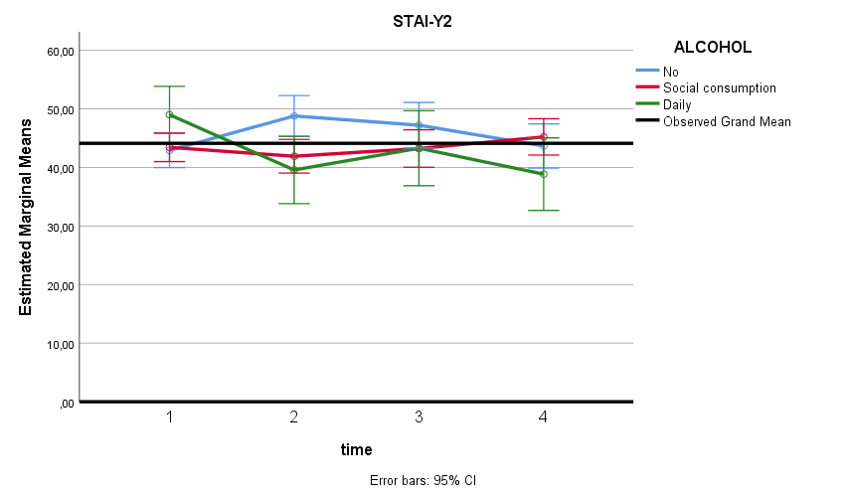
STAI-Y2 Scores of Alcohol

