Supplementary Material

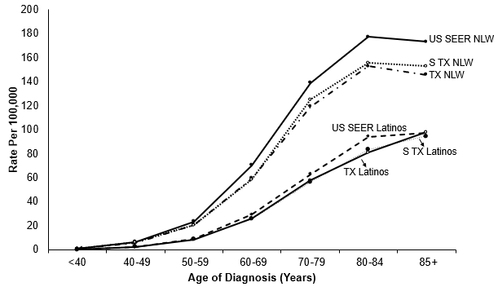

Supplemental Figure 1. Age-specific incidence rates of bladder cancer by race/ethnicity, 1995-2015
NLW: non-Latino whites; STX: South Texas; TX: Texas; US SEER: United States Surveillance, Epidemiology, and End Results Program

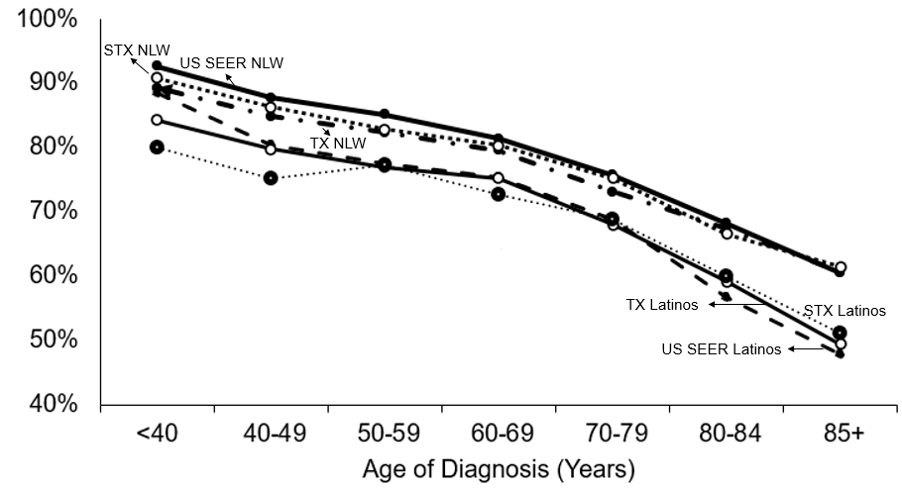
Supplemental Figure 2. Age-specific 5-year relative survival rates of bladder cancer by race/ethnicity, 1995-2000
NLW: non-Latino whites; STX: South Texas; TX: Texas; US SEER: United States Surveillance, Epidemiology, and End Results Program

