SUPPLEMENTARY INFORMATION
Docetaxel with or without ramucirumab after platinum-based chemotherapy and checkpoint inhibitors in advanced urothelial carcinoma:
a pre-specified subgroup analysis from the phase 3 RANGE trial

By Alexandra Drakaki et al.

Table of Contents:

Fig./Table no. | Title | Page no.
Figure S1 | CONSORT diagram showing derivation of the post-ICI population | 2
Figure S2 | Duration of RANGE treatments and tumor response in the prior-ICI patient subgroups. | 3
Figure S3 | Kaplan-Meier plot of (A) PFS and (B) OS for post-ICI population | 4
Table S1 | Summary of RANGE drug exposure of prior-ICI patients | 5
Table S2 | Overview of RANGE trial adverse events of prior-ICI patients | 6

Figure S1. CONSORT diagram showing derivation of the post-ICI population

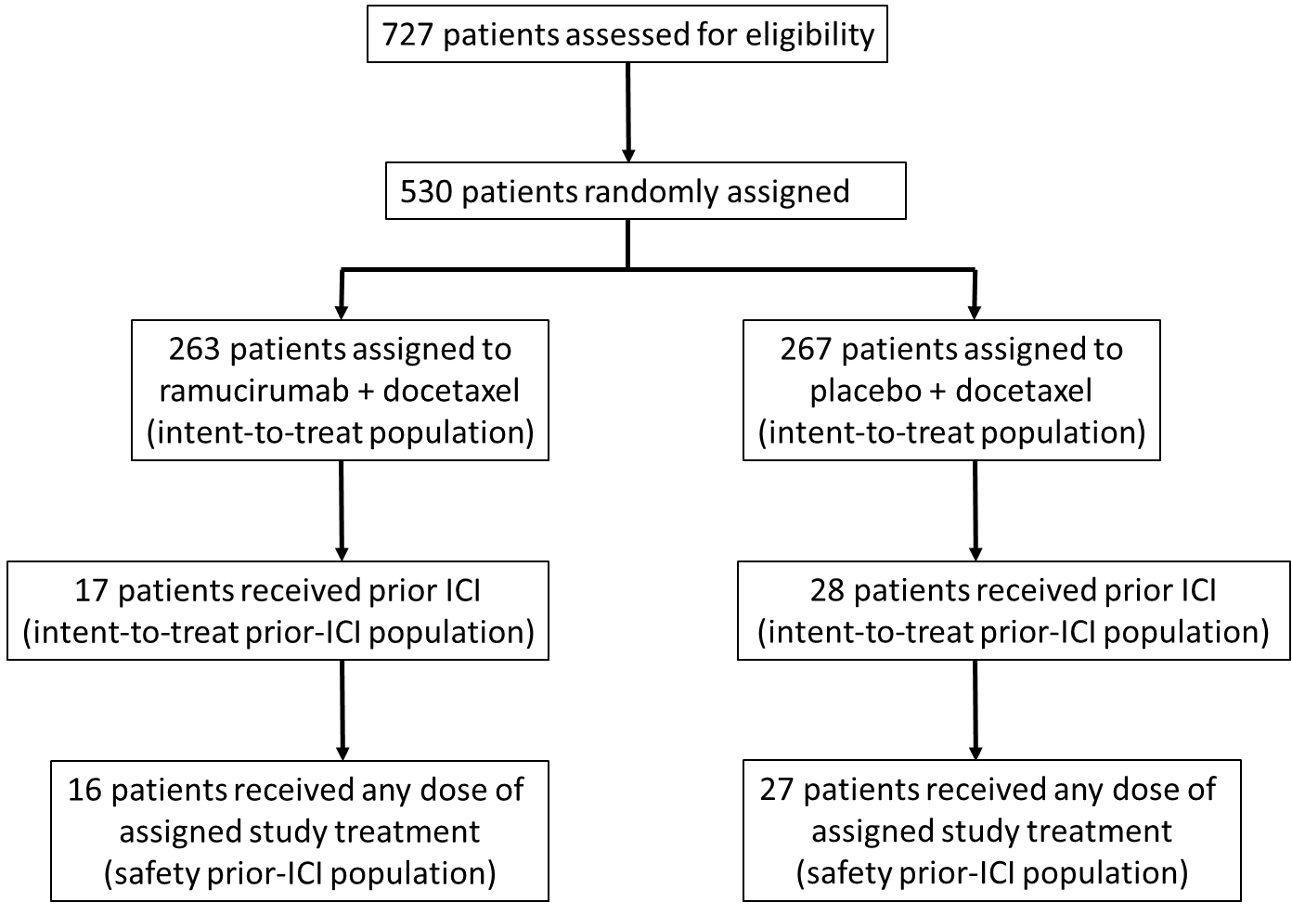

Figure S2. Duration of RANGE treatments and tumor response in the prior-ICI patient subgroups.

The prior-ICI patient population is shown by RANGE treatment arm, ramucirumab/docetaxel (left) and placebo/docetaxel (right), with an indication of duration of RANGE treatment (mo) and best tumor response (see color key). Patients on each treatment arm were assigned an identification number; the same patient numbers are reflected in Figure 1.

Figure S3. Kaplan-Meier plot of (A) PFS and (B) OS for post-ICI population

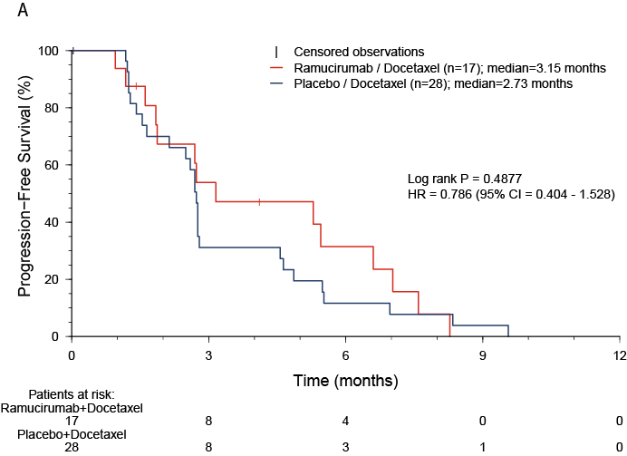

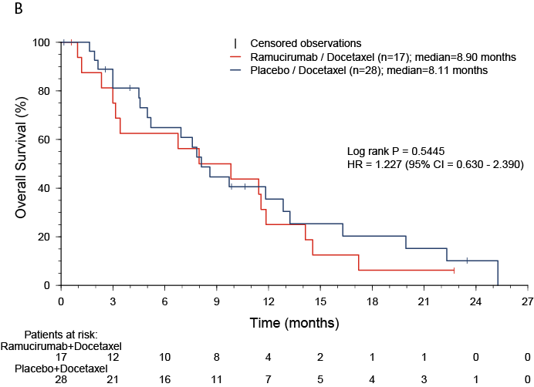

Table S1. Summary of RANGE drug exposure of prior-ICI patients

 | Ramucirumab + docetaxel  (n=16) | Placebo + docetaxel  (n=27)
Patients receiving ramucirumab or placebo, n (%) ª | 16 (100) | 27 (100)
Median cycles received, (IQR) ^{b} | 3.5 (2.0 – 8.0) | 4.0 (2.0 – 6.0)
Median duration of therapy (IQR) (weeks) | 10.8 (6.0 – 25.4) | 12.0 (7.0 – 19.0)
Patients receiving docetaxel, n (%) ª | 16 (100) | 27 (100)
Median cycles received, (IQR) ^{b} | 3.5 (2.0 – 6.0) | 4.0 (2.0 – 6.0)
Median duration of therapy (IQR) (weeks) | 10.8 (6.0 – 18.0) | 12.0 (7.0 – 17.7)

Abbreviation: IQR=interquartile range.
ª Number of patients who received at least one dose of study drug ramucirumab or placebo either partial or complete.
^{b} Patient was considered to have received a treatment cycle after receiving at least one dose, either partial or complete.

Table S2. Overview of RANGE trial adverse events of prior-ICI patients

 | Ramucirumab + docetaxel  (n=16) | Placebo + docetaxel  (n=27)
Patients with ≥1 TEAE, n (%) ª  Related to study treatment ^{b} | 16 (100)  15 (93.8) | 27 (100)  25 (92.6)
Patients with ≥1 CTCAE grade ≥3 TEAE, n (%)  Related to study treatment | 11 (68.8)  9 (56.3) | 21 (77.8)  10 (37.0)
Patients with ≥1 SAE, n (%)  Related to study treatment | 8 (50.0)  6 (37.5) | 13 (48.1)  6 (22.2)
Patients who discontinued study treatment due to AE, n (%)  Related to study treatment | 2 (12.5)  0 | 2 (7.4)  1 (3.7)
Patients who discontinued study treatment due to SAE, n (%)  Related to study treatment | 2 (12.5)  0 | 1 (3.7)  0
Patients who died due to AE on study treatment, n (%)  Related to study treatment | 1 (6.3)  0 | 1 (3.7)  0
Patients who died due to AE within 30 d of discontinuation  of study treatment, n (%)  Related to study treatment | 1 (6.3)  0 | 1 (3.7)  0

Abbreviations: AE=adverse event; CTCAE= Common Terminology Criteria for Adverse Events; SAE=serious adverse event; TEAE=treatment-emergent adverse event.
ª Subjects may be counted in more than one category.
^{b} Relatedness was judged by the investigator.

