SUPLLEMENTARY APPENDIX (ONLINE ONLY)
Table of Contents
Table A1. CADI-05 composition: 29
Table A2. Determination of Sample Size 30
Table A3. Recurrence information after CADI-05 treatment 31
Table A4. Response to therapy with checkpoint inhibitors 32
Table A5. CADI-05 trial investigators & institutions 33
Fig A1. TIL evaluation using Hematoxylin and eosin stain: 34
Fig A2. Correlation of DSC3 expression and TIL infiltration for durable response to therapy 35

Table A1. CADI-05 composition:

CADI-05 description
CADI-05 contains heat killed suspension of Mycobacterium w (Mw), a nonpathogenic, cultivable atypical Mycobacterium.
Each dose of 0.1 ml of Mycobacterium w contains:
Mycobacterium w (heat killed) 0.50 x 10⁹
Sodium Chloride I.P. 0.90% w/v
Thiomersal I.P. (As a Preservative) 0.01% w/v
Water for injection I.P. q. s. to 0.1 ml

Table A2. Determination of Sample Size
The planned sample size was considered as per following formula:
C = N x (p₀ + [(Z_{α/2} / (Z_{α/2} + Z_{1-β/2})) x (p₁ – p₀)
Where,
C = Number of “cut-off” subjects to distinguish between the lower (p₀) and higher (p₁) success rates.
N = Number of total subjects = 21.
Z_{α/2} = Standard normal variate corresponding to5% level of significance (=1.96) and Z_{1-β/2} is the standard normal variate for power (=0.80).
Using A’Hern’s method [1], for p₀ = 20%, p1 = p₁%, at least 7 (31-33%) of 21 patients should be relapse-free at 1 year.
Reference:
A'Hern R. Sample size tables for exact single-stage phase II designs. Statistics in Medicine. 2001; 20(6):859-866.

We determined that a cohort of 20 patients would be sufficient to give an 80% probability of rejection of a HG recurrence-free survival (RFS) rate of 10% with an exact 5% one-sided test when the true HG RFS rate was 35%. The operating characteristics for this Fleming design were calculated exactly with the binomial distribution described by A’Hern. The hypothesis that the response rate was equal to or less than the reference rate was rejected if five or more of the 20 patients achieved HG RFS at 12 months.

Table A3. Recurrence information after CADI-05 treatment
Total Recurrence | 13*
- No change in stage and/or grade | 7
- Change in stage only | 1 ( T1high to CIS high)
- Change in grade only | 2 (both T1high to T1 low)
- Change in stage and grade | 2 ( T1high to Ta low; Ta high to T1 low)
*One non-compliant was recurrence free at last follow-up but is considered to have a recurrence at same stage and grade

Table A4. Response to therapy with checkpoint inhibitors
 |  | Marker | Cut off value | Objective Response Rate (ORR) | Durable response at six months | Reference
Lung
 | Keynote-024 | PD-L1 | ≥ 50% | 45% |  | 38
 | Keynote-010 | PD-L1 | ≥ 01% | 18% |  | 38
Urothelial cancer
 | Keynote-052  Pembrolizumab | PD-L1 | >10% | 47% |  | 38
Gastric cancer
 | KEYNOTE-059  Pembrolizumab | PD-L1 | ≥1% | 13.3% | 58%> six months | 38
Cervical cancer
 | KEYNOTE-158  Pembrolizumab | PD-L1 | ≥1% | 14.3% | 91%> six months | 38

Table A5. CADI-05 trial investigators & institutions

Sr. No. | Investigators ( Qualifications) | Institutions
1 | Dr. Sushil Bhatia  (M.Ch.-Urology, DNB - Urology) | Choithram Hospital & Research Centre, Manik Bagh Road,  Indore- 452 014 (M.P.)
2 | Dr. Anup Kundu  (M.Ch.-Urology) | Dept. of Urology, Institute of Post Graduate Medical Education & Research,  S. S. K. M. Hospital, 244,  A.J. C Road  Kolkata- 700 020
3 | Dr. Jitendra Amlani  (M.Ch.-Urology) | Urocare Hospital,  Vidyanagar Main Road, Near Patel Boarding,  Rajkot- 360 002 (Gujarat)
4 | Dr. N. K. Mohanty  (M.Ch.-Urology, DNB - Urology) | V M Medical College and Safdarjang Hospital,  Sri Aurobindo Marg,  New Delhi – 110 029
5 | Dr. S. K. Singh  (M.Ch.-Urology) | Department of Urology,  Post Graduate Institute of Medical Education and Research,  Chandigarh – 160 012
6 | Dr. Ketan Shukla  (M.Ch.-Urology) | Aarogyam Specialty Hospital,  Soham I, Near Navrang High School,  Near Darpan Six Road,  Navrangpura, Ahmedabad – 380 014 (Gujarat)
7 | Dr. H Krishnamoorthy  (M.Ch.-Urology) | Dept. of Urology,  Lourdes Hospital,  Kochi-682012
8 | Dr. Rajeev Sood  (M.Ch.-Urology) | Department of Urology,  Dr. Ram Manohar Lohia Hospital & PGIMER,  New Delhi-110001
9 | Dr. Purshottam K Puri  (M.Ch.-Urology) | Department of Urology,  Indira Gandhi Medical College,  Shimla-171001

Fig A1. TIL evaluation using Hematoxylin and eosin stain:
(A) No TIL; (B) Only sTIL; (C) sTIL + iTIL
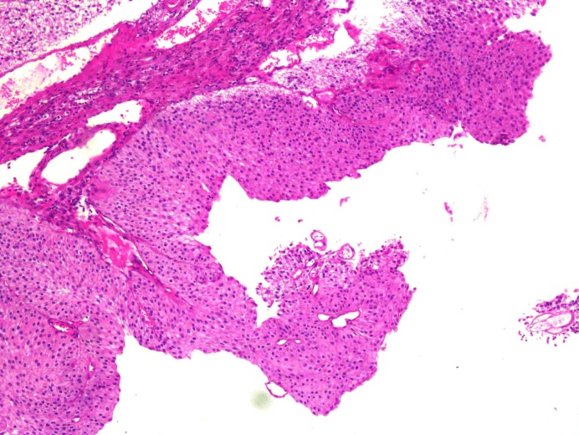
(A)
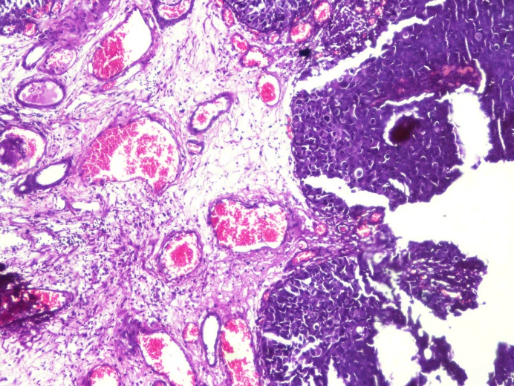
(B)
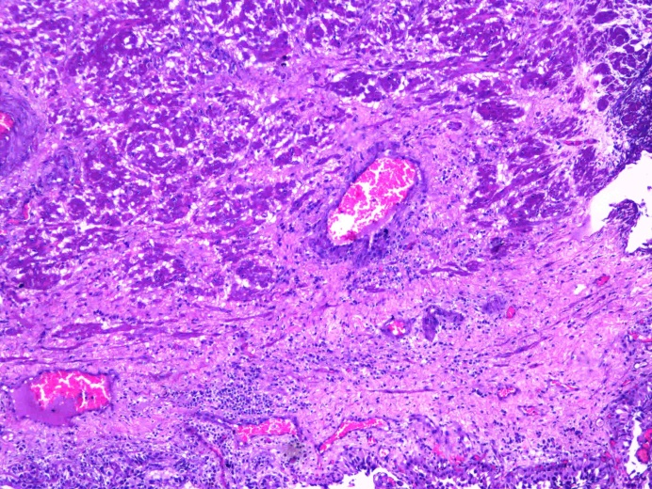
(C)

Fig A2. Correlation of DSC3 expression and TIL infiltration for durable response to therapy

