†Bacillus Calmette–Guérin
‡Mitomycin

Figure S1: Flow chart of the method conducted during the study

Retrospective chart review of patients undergoing TURBT* at SVHM** between 1995-2015 (n=366)

Patients without recurrence (n=113)
Patients with recurrence (n=142)
Total number of patients after exclusion criteria (n=255)
Exclusion criteria: (n=111)
- Diagnostic TURBT† NOT performed at SVHM‡.
- Patients with a diagnosis other than pTa or pT1 disease.

†TURBT = Transurethral resection of bladder tumour
‡SVHM = St. Vincent’s Hospital Melbourne
Flow chart detailing the method of data collection, exclusion criteria and stratification of patients into “recurrence” or “without recurrence” groups.

Figure S2: EAU†, comparison of 2004 WHO and 1973 WHO grading systems
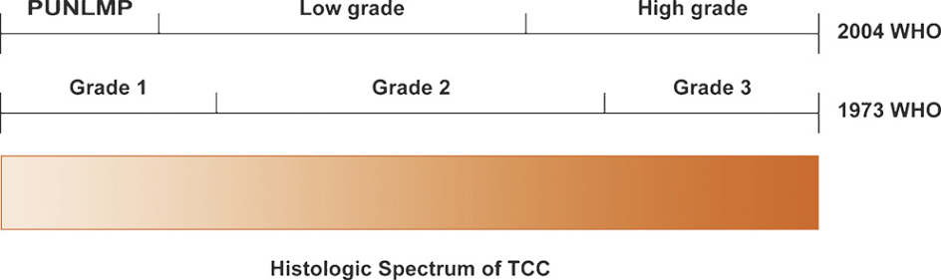
†EAU = European Association of Urology
PUNLMP = papillary urothelial neoplasm of low malignant potential
Conversion from the 2004 WHO to the 1973 WHO grading systems. PUNLMP (WHO 2004) will be reassigned to Grade 1 (WHO 1973). Low grade (WHO 2004) will be reassigned to Grade 1 or Grade 2 (WHP 1973). High grade (WHO 2004) will mostly be converted to Grade 3 (WHO 1973).
MacLennan GT, Kirkali Z, Cheng L. Histologic grading of noninvasive papillary urothelial neoplasms. European Urology 2007; 51(4):889-97.’

Table S1: EORTC risk table for recurrence
Clinico-pathologic factor | Score
Number of tumours
Single | 0
2 | 3
≥ 8 | 6
Tumour Size
< 3cm | 0
≥ 3cm | 3
Prior recurrence rate
Primary | 0
≤ 1 recurrence/year | 2
> 1 recurrence/year | 4
T category
Ta | 0
T1 | 1
CIS*
No | 0
Yes | 1
Grade
G1 | 0
G2 | 1
G3 | 2
Total Score† | 0-17

*Carcinoma in situ
†Patients were risk stratified into: low risk (score 0), intermediate risk (score 1-4), high risk (score 5-9), and very high risk (score 10-17).

Sylvester R, van der Meijden A, Oosterlinck W, Witjes J, Bouffioux C, Denis L et al. Predicting Recurrence and Progression in Individual Patients with Stage Ta T1 Bladder Cancer Using EORTC Risk Tables: A Combined Analysis of 2596 Patients from Seven EORTC Trials. European Urology. 2006;49(3):466-477.

Table S2: Exact (binomial method) comparing observed proportion vs proportion expected based on EORTC 3 year recurrence group

 | Recurrence within 3 years
EORTC 3 year Recurrence groups | No | Yes | Total | EORTC 3 year predicted percentage recurrence | Actual percentage recurrence [95% CI] | p-value(*)
Score 0 | 7 | 3 | 10 | 25 | 30 [7-65] | 0.72
Score 1-4 | 15 | 24 | 39 | 40 | 62 [45-77] | 0.008
Score 5-9 | 1 | 2 | 3 | 56 | 66 [9-100] | 1.00
Score 10-17 | 0 | 0 | 0 | 75 | 0 | Cannot Estimate
Grand Total  *Exact binomial method | 23 | 29 | 52

Table S3: Exact (binomial method) comparing observed proportion vs proportion expected based on EORTC 5 year recurrence group
 | Recurrence within 5 years
EORTC 5 year Recurrence groups | No | Yes | Total | EORTC 5 year predicted percentage recurrence | Actual percentage recurrence [95% CI] | p-value(*)
Score 0 | 1 | 4 | 5 | 31 | 80 [28-100] | 0.03
Score 1-4 | 22 | 8 | 30 | 46 | 27 [49-74] | 0.04
Score 5-9 | 3 | 1 | 4 | 62 | 25 [0.6-81] | 0.04
Score 10-17 | 0 | 0 | 0 | 78 | 0 | Cannot Estimate
Grand Total | 26 | 13 | 39

*Exact binomial method

